Journal Challenge
Winter
Winter is here so go out wandering with eyes wide-open and a camera in hand. Take pictures that present themselves to you as you make your way home, to work, or a vacation. Take a journey out to find those winter scenes, but remember to keep you and camera warm! If condensation gets in, it can damage the camera! Try just Black & White either while shooting or altering in Photoshop. *Remember to try vertical format too!

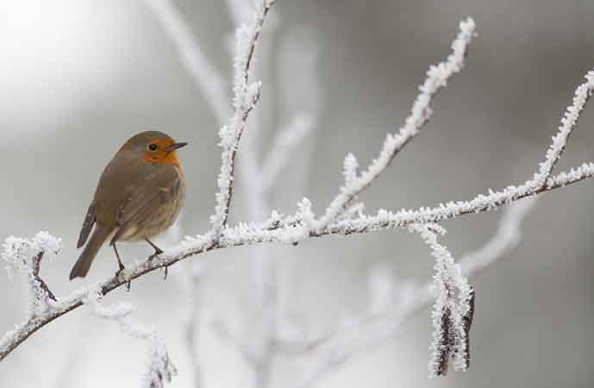
Take at least 5 different Winter shots for your journal. Journal prompt: How did you come across this winter scene? What about this scene caught your eye to take the shot? Was there anything that you wanted to alter while shooting? Were you able to keep the “whites” white? Did you need to edit after shooting? What did you do?
