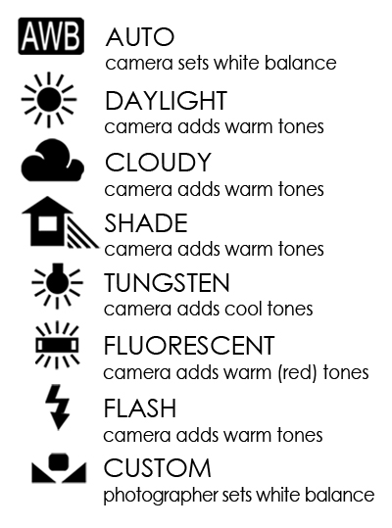
White Balance
*The reason we adjust white balance is to get the colors in your images as accurate as possible.
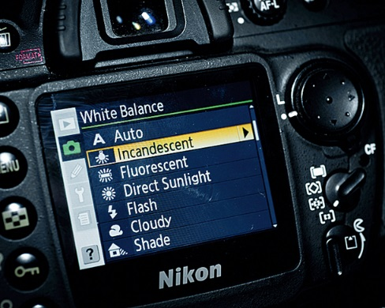

Directions:
- Set up a “scene” or still life.
- Take a picture of the “scene” using each of the different White Balance settings.
  - (Auto, Daylight, Cloudy, Shade, Tungsten, Fluorescent)
- To change the White Balance, press the WB button on the camera and then select the desired setting.
- Print all prints to go in your Journal and label what each White Balance was. Journal the effects each created within the photo. What happened to the colors & the whites?

Need to take the pictures in the following locations:
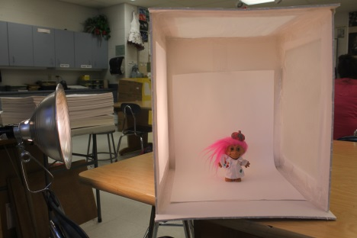
- Near a window
- Sitting in a room with lights on
- Using the Light Box with a Studio Light on
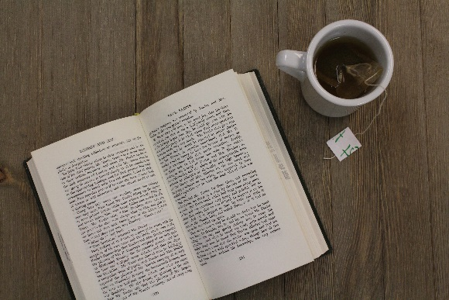
- Outside

