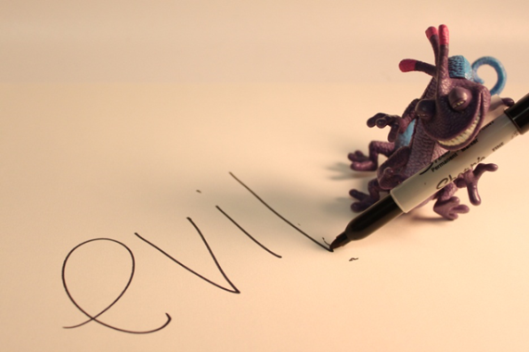
Toy Portrait
The objective is to give a toy personality, emotion, a story.

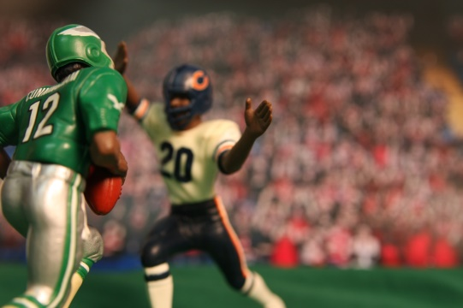
*Can be simple or complex.
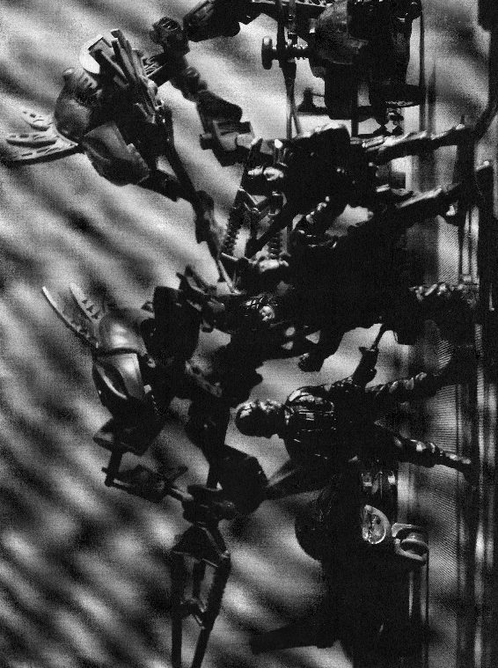
*Can be in Color or B&W.
*Can have one or more toys in the frame.

*Think about how lighting will affect the overall mood you are trying to create. Are you going to use studio or natural lighting? Indoors/Outdoors?
*Staged background/printed background?

Turn in your BEST shot & Contact Sheet of at least 15 shots. Write about your toy’s story, the challenges you had in creating the scene and why it is successful or not. What would you do differently if you could do it over?

