Toilet Paper Roll Book

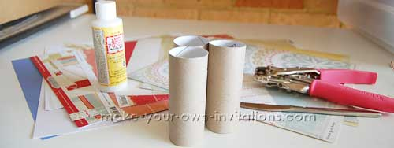
Materials
- 3 or more toilet rolls
- folder binder rings
- Scrapbook patterned papers to decorate
- Ribbon or fibers
- A Bone folder - a ruler or dull dinner knife works just as good
- A hole punching tool
- Adhesive - I used regular PVA glue (white glue) and an old credit card or piece of firm card to spread the glue evenly
- Paper trimmer or scissors

Directions

Step 1
Take your cleaned up toilet rolls and flatten them. Use the bone folder to firmly crease the folds so that they are as flat as you can make them.
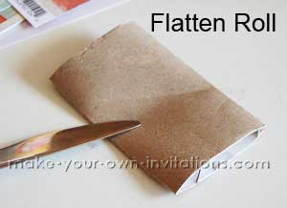

Step 2
Now measure your flattened roll to get the 'roll length' and the 'roll width'
Cut a piece of Patterned cardstock to be:
roll length + 1" by 2 x roll width then add on an extra 1"
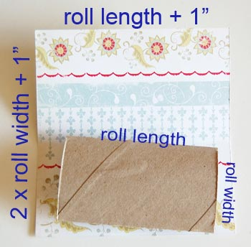
Example
Measurements
Length = 5
Width = 2.5
Example Final Measurements
Length = 6
Width = 6

Step 3
Align one side of the roll with the edge of the paper and fold it over. Fold over again the remaining small piece. You will now have three panels - the top flap, the middle and bottom panels.
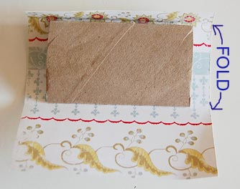

Step 4
Now spread some glue evenly over one side of the flattened toilet roll. Stick the roll to the middle panel. Be sure to center it. Now take a pair of scissors and cut four small wedges in the card as shown below. This will enable us to tuck in the overhanging edges easily.
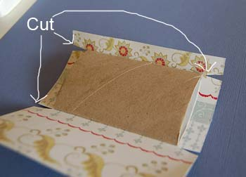

Step 5
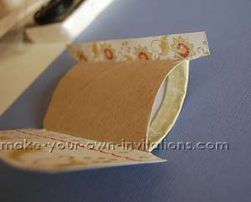
Spread a small amount of glue onto the overhanging edges and tuck them inside the roll and press firmly for a good 20 seconds to ensure they stick.

Step 6
Glue down the shorter top flap and tuck in the edges.
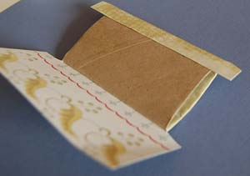

Step 7
Then glue down the last panel and overhanging edges.
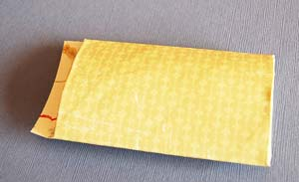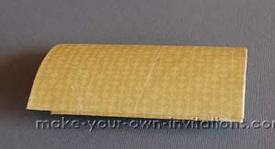

Step 8
Repeat for the remaining toilet rolls. Cover them in the same or coordinating patterned papers.

Step 9
Take your hole punch tool and punch two holes a quarter inch in from the side of the flattened rolls for binding. My holes are also 3/4" from the top and bottom of the rolls.
You don't have to use rings for binding - you can thread through some ribbon and fibers if you wish.

Step 10
Measure and cut three cardstock tags that will fit into the pockets that will be created by the bound pages. I measured my tags to be a little longer so that they will protrude from the pockets.
Punch a hole approx 1/2" in from the top of each tag in the center. Use a corner rounder punch to round of the corners if you wish.
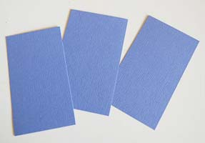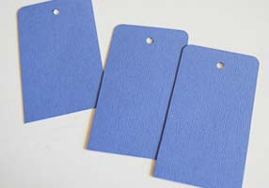
Thread the pages onto binder rings and tie on some pretty, coordination lengths of ribbon to embellish the album. Embellish the tags with ribbon as well.

