Thru Glass

*Find an object/subject to set behind the glass
If you can’t see the subject through the glass, try another subject.
Also, remember Composition!
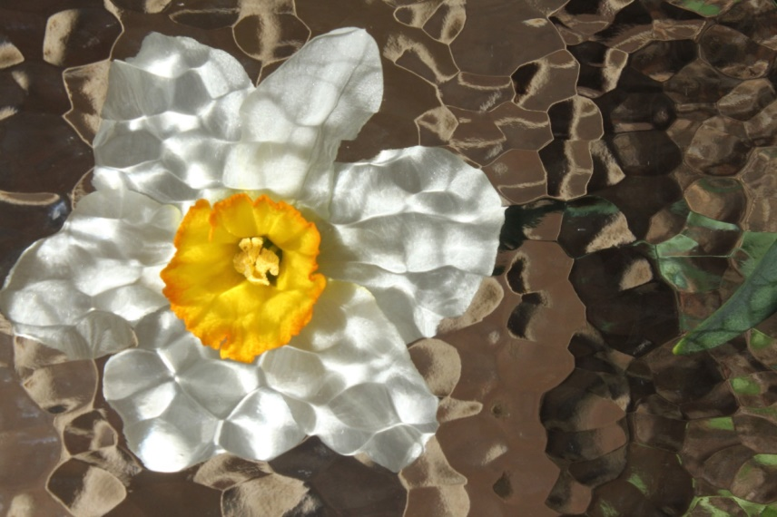
*Make sure there is enough light
Use either natural or studio lights
*And shoot!
*Effect looks like you did it in Photoshop!
