Some key principles to remember for Bokeh
- Get close to the subject.
- Stay far away from the background.
- Keep aperture wide open.
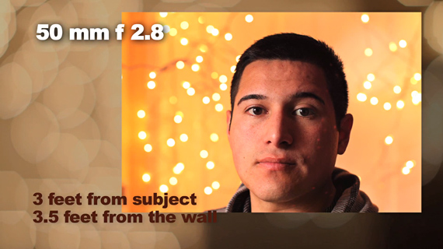
- Pinpoint lights (e.g. light bulbs, stoplights) are better than light screens (e.g. fluorescents, billboards).

Not blurry enough

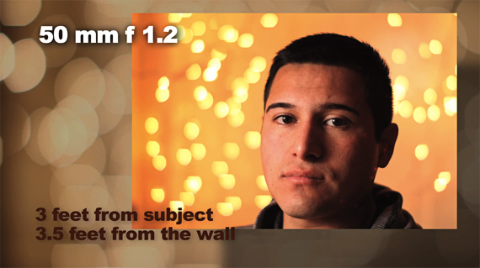

Better bokeh

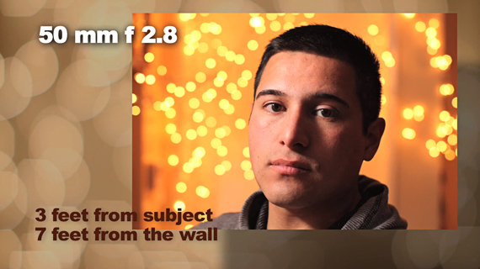

Nicer when farther from wall

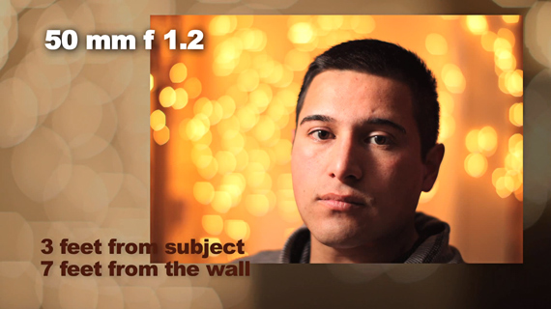

Stepping closer to the subject decreases depth of field

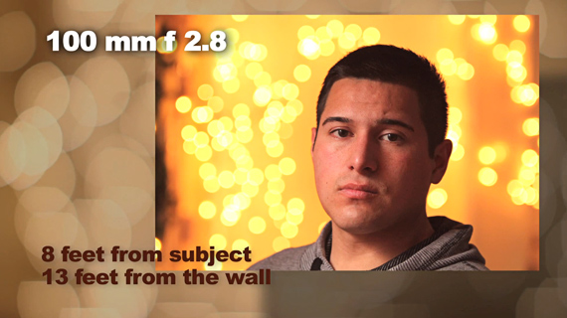
Effect is similar to the photo shot with the 50mm f/2.8 lens at 2.5 feet from subject; 13 feet from the wall

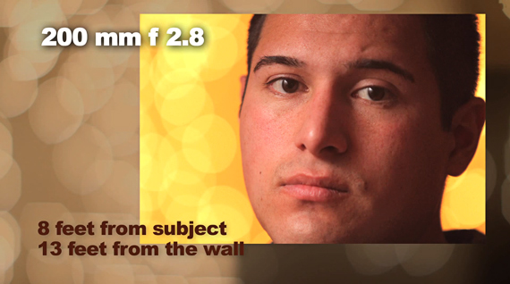

Head size increases but bokeh is really nice

As you can see, you can achieve similar Bokeh effects with different lenses by studying where to position yourself relative to the subject and background. Having your subject shift a few feet forward or backward could make a huge difference in the shape, size and opacity of the out-of-focus lights in your background.
Billboards create unpredictable patterns and colors of light
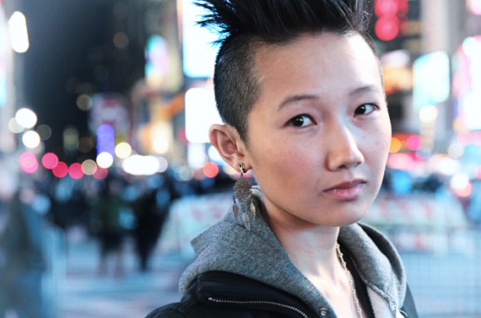
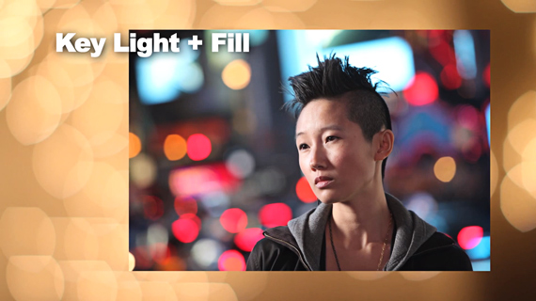
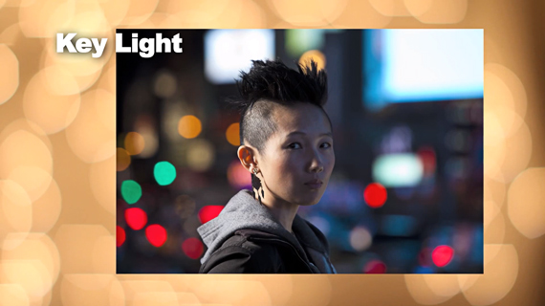
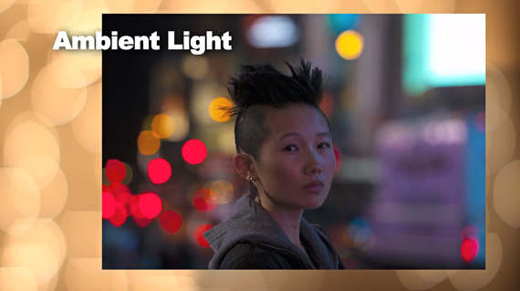

- Choose a Lens with the Largest Aperture
  - Use f/1.4, f/.18 or even f/2.8.
- The larger the aperture the larger the orbs will be. So if you set the aperture to f/1.4 the orbs will be larger than if you were to set the aperture at f/2.8.
- If you want larger orbs place the subject farther away from the lights. If you want smaller orbs place the subject closer to the lights.
How it was achieved the cupcake photo:
- 1. They hung white Christmas lights from the curtain rod in another room.
- 2. Placed the cupcake on the table a good distance away from the lights.
- 3. Should use a tripod.
- 4. Can wait until it was dark out and turn off the lights.
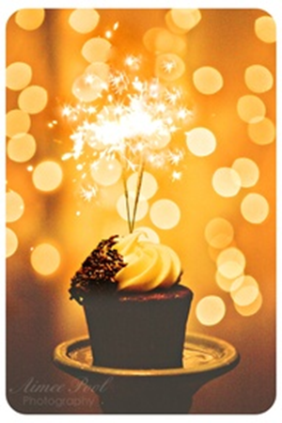
- 5. Set camera in manual mode (M).
  - Set ISO at 1000.
    - If it’s too dark, increase the ISO level rather than the f-stop number.
  - Set aperture at f/2.8 (as large as it can go).
  - Set Shutter Speed around 1/50 of a second.
- 7. Get as close to the subject as possible & focus on it.

