Splash of color
Objective | This exercise is to help you learn how to add a “splash” of color to a B&W photo to create emphasis and interest.
Open Image | open photoshop>File>Open or right-click on image from folder>Open with>Photoshop
Duplicate image | Layer>Duplicate Layer  Before you click ok, select New in the Destination drop menu  Name it “Splash of Color”
New Adjustment Layer | 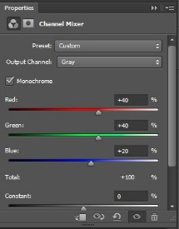  Layer>New Adjustment Layer>Channel Mixer  Click on the Monochromatic Box  Optional Step: Can make color (Red, Green, Blue) adjustments by moving the sliders.
Brush | 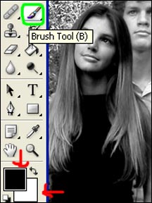  Make sure the Channel Mixer Layer is selected in the Layers Panel.  Click on the Brush Tool in the Tools Panel on the left.  Make sure Black is on top of White at the bottom of the Tools Panel.  Using black, carefully brush over the parts of the picture that you want to be in color,  You made need to adjust brush sizes for the small details.  *If you touch an area you didn’t want in color, switch the colors so White is on top. Use the double-head arrow to go back & forth.
Save | File>save  Save the Photoshop File in your Photo Folder  File>save as  Change the file format to a jpeg in your Photo Folder  FILE>SAVE AS  Find your USB/Flash Drive under Computer  Save to your USB/Flash Drive for a back up.

