Selective Sepia

Step 1: Open an image into Photoshop.

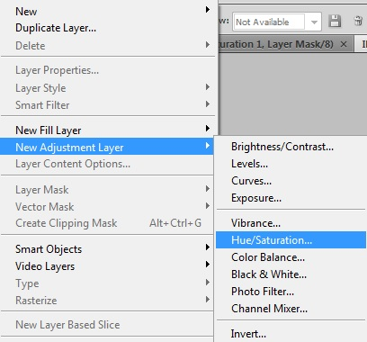

Step 2: Create a Hue/Saturation adjustment layer

(Layer>New Adjustment Layer> Hue/Saturation)

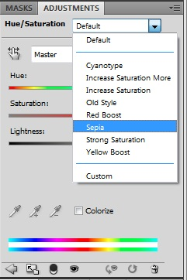
Step 3: With the Hue/Saturation Layer, select under Preset>Sepia (it’s in a drop down menu)

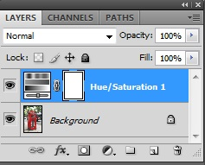
Step 4: Activate the layer mask by clicking on the layer mask thumbnail in the Layers pallet.

Step 5: Select the Brush tool and erase the areas where you don’t want the sepia tone to be applied to.
Make sure Black is on top!

