Journal Challenge
Secret Beauty
The idea was that there are special places you have come to know that spark something deep in your photographic soul, places that only “locals” might know. It could also be places that you had come upon in your travels when you took a turn off the beaten track.
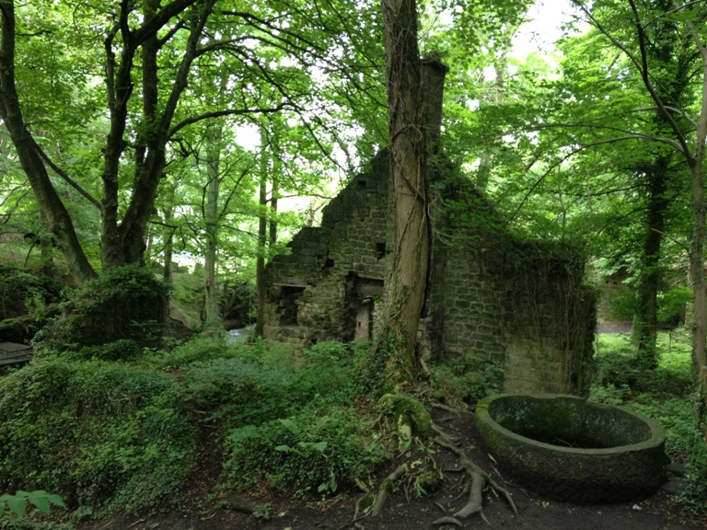
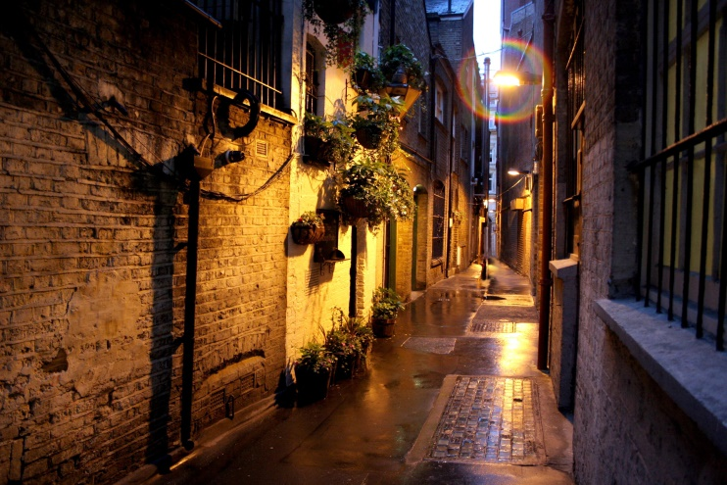
Take at least 5 different shots for your journal. Journal prompt: How did you approach this challenge? How and where did you find this place? Has it just be recently found or has it been your spot for a while?
