Scanography

Step 1: Before you start with creating images using scanography, make sure the glass platen of the scanner is clean. This is very important as even a tiny dust particle will show-up in your final image.
Step 2: After cleaning the scanner, arrange the object(s) you want to photograph. Use your creativity and imagination to do this! It could just be a slice of a tomato or a collage of various things you like. Movement of the object placed will create a different effect.
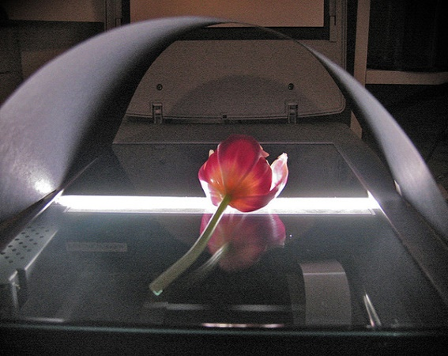
***Scanners were not originally made to create art, placing liquids and other objects can leave scratches on it. Make sure to use a plastic barrier between the objects and the glass platen. Also, after you are done with the process, clean the glass platen if there’s any pollen on it to avoid scratches.
Step 3: Turn the computer on FIRST and log in and then turn the scanner on. .
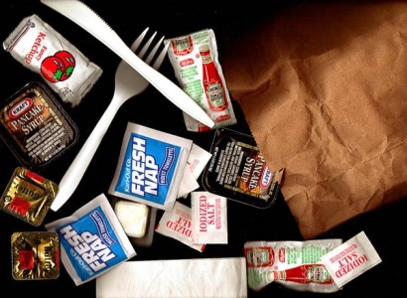
Step 4: Press the object (if possible but not too hard). This is because the depth of field of the scanner is low, the closer the object is to the glass bed the sharper it will get. You can avoid this step if you want to get a blurred-effect in some parts of the image. ***Don’t forget about COMPOSITION!***
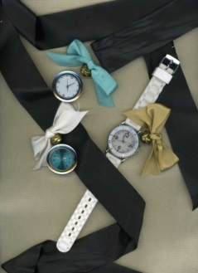
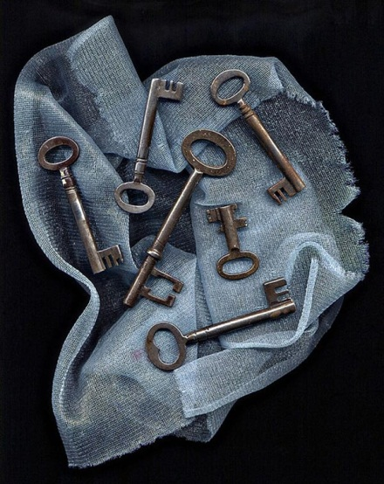
Step 5: Once the object is ready to be scanned, click on the scan icon on the desktop of the computer, click PREVIEW when you are ready to scan. Adjust the objects if required. Repeat this process until you are completely satisfied. Click SCAN when you are ready for the final scan. Keeping the lid of the scanner open in a dark room will create a beautiful black background or take a piece of mat board to create a tent.
Step 6: To save your image and print. Put in your journal and journal/critique. Why did you choose the objects you did? How did your objects and composition reflect the theme you were attempting? What would you do differently if you did it over again and why?

