Remove Unwanted Items in a Photo
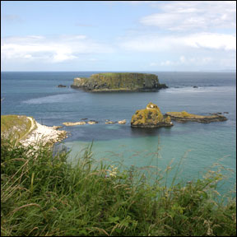
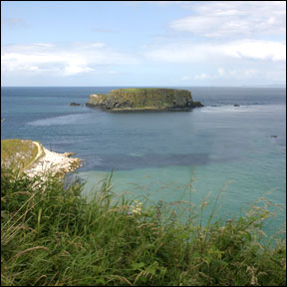

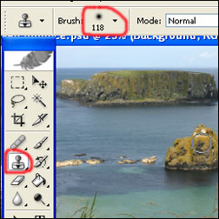
This tutorial is to help you learn how to remove unwanted items from a photo using the Clone Stamp Tool. For this photo (in order to simplify it and draw more attention to the main island) I removed the chain of little islands. Once you have your photo open in Photoshop:
1. Select the Clone Stamp Tool from the toolbar, pick a good sized brush and set the opacity to about 95%.

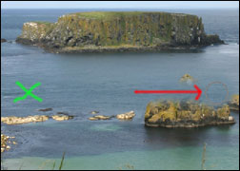
2. Hold alt and click somewhere to take a good sample. (Wherever you take a sample, that’s what you’re going to be drawing in place of the removed object).

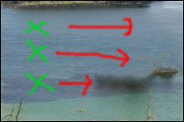
3. Release alt and carefully click and drag the mouse over the item you wish to remove. (You will notice that the spot where you took the sample will follow your movements).

4. Continue to repeat steps 2 and 3 until the unwanted object is completely gone. You might have to change techniques a little based on available places to take a good sample. With practice this tool is very valuable.

