Removal of unwanted objects
Objective | This exercise is to help you learn how to remove any unwanted objects within your photograph by using the Clone Stamp Tool.
Open Image | open photoshop>File>Open or right-click on image from folder>Open with>Photoshop
Duplicate image | Layer>Duplicate Layer  Before you click ok, select New in the Destination drop menu  Name it “Unwanted Object”
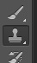  Clone stamp | Select the clone stamp tool on the tool bar. select a brush size and set the opacity to about 95%.  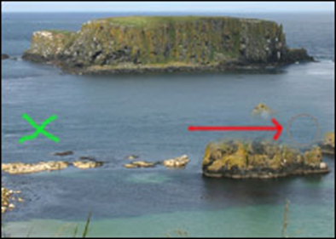  In the example to the right, the unwanted object is the rocks under the arrow. The X is the area that a clone/sample will be taken to cover the unwanted rocks. Press Alt & click to create your clone/sample.  - Release Alt then carefully click & drag the mouse over the unwanted object. (You will notice that the spot where you took the clone/sample will follow your movements.)  Repeat Step 1 until the unwanted objects are removed.
Save | File>save  Save the Photoshop File in your Photo Folder  File>save as  Change the file format to a jpeg in your Photo Folder  FILE>SAVE AS  Find your USB/Flash Drive under Computer  Save to your USB/Flash Drive for a back up.

