Photoshop depth of field effects: how to make an f/22 exposure look like f/1.2
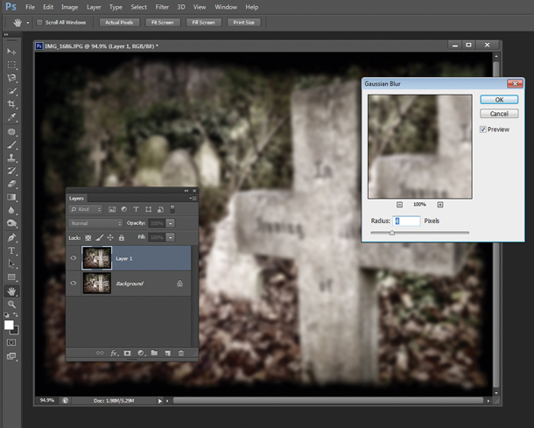
How to create shallow depth of field in Photoshop

01 Duplicate and blur
Duplicate your original image layer. Go to Layer then Duplicate Layer. Next, go to Filter> Blur & blur the copy by using the Gaussian Blur. The amount of blur you apply will depend on the content and composition of your image.

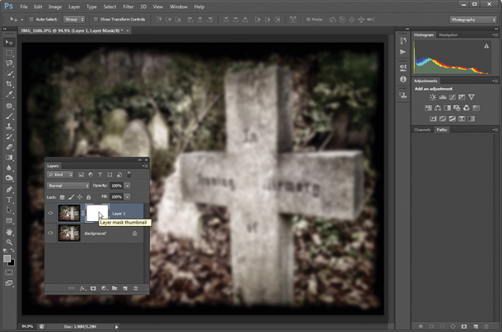
02 Create the mask
With your blurred layer selected, click the Add a Mask button at the base of the Layers Panel. Your mask appears as a white box next to your layer thumbnail. Click to select it.

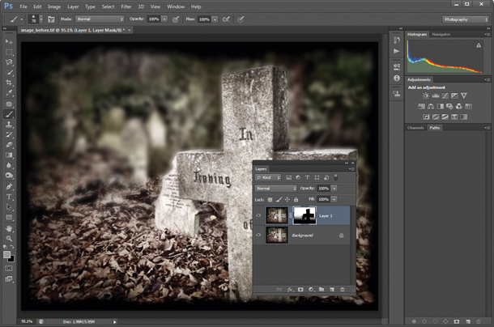

03 Reveal sharp areas
Make use of the Brush tool as well as Photoshop’s various other selection and fill tools to paint black onto the mask to reveal sharp areas from the lower Background layer.

