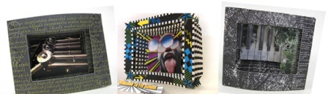
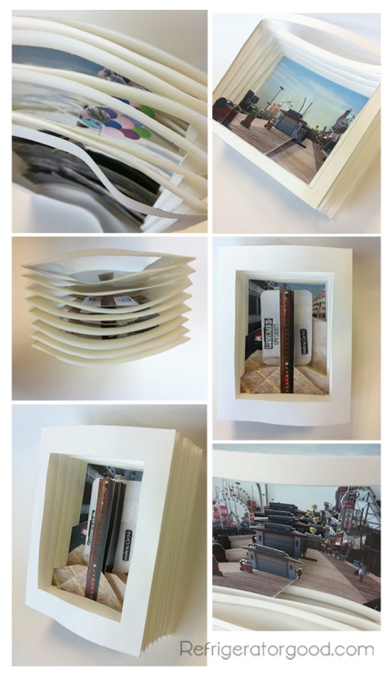
Photo Tunnel

Find an image that can have up to 6 “layers” to it.
Create separate layers/and pages in Photoshop for printing. Using the polygonal selection tool they subtract from the original image. [see below] Each file is printed separately and then the white area is cut away with an X-acto blade.
TIP: Card stock paper works best for the pages and sides of the book.
After cutting the white areas away you may begin creating the sides of the book. It is important that the folds of the accordion sides are the same width. Smaller folds work better for book with 6 pages or more.
Rubber cement works great for attaching the pages to the accordion folds. Paint it on the back of the pages and the inside of the fold, let it dry and then attach. {the dry rubber cement will stick to itself without wrinkling the pages.}
