Photo Tinting in Photoshop
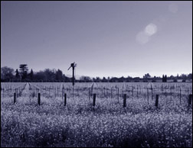
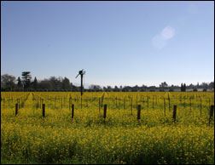
Without Tinting

With Tinting
This tutorial is to help you learn how to create any kind of tone for your photo that you want. With this technique you can make all sorts of unique tones that many graphic artists use to create fascinating scenes. This tutorial will involve desaturation and color balance. Ok, once you have your picture open in Photoshop:
1. Convert your photo to black and white by Desaturating it. (Image>Adjustments>Desaturate)
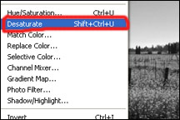
2. Create a New Color Balance Adjustment Layer (Layer>New Adjustment Layer>Color Balance)
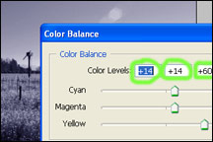
3. For the Blue tone as shown above I adjusted the colors to the following:
Red: +14
Green: +14
Blue: +60

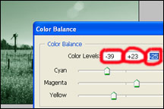
4. Another Possibility could be a unique greenish tint as shown on the left. For the greenish tint I adjusted the colors to the following:
Cyan: -39
Green: +23
Yellow: -25

