Photo “inside” text
Objective | This exercise is to help you learn how to put a photo image INSIDE text for emphasis, interest & unity between the image and the word/phrase.
Open Image | open photoshop>File>Open or right-click on image from folder>Open with>Photoshop
New Document | file>new
Fill | edit>Fill  Under Contents select Black in the drop down menu.
Text | Select the Text Tool on the Tool Panel  Click the Text Color box to change the color to WHITE  Create a Text box on the Black Document.  Select text font and size
New Layer and Add Image | 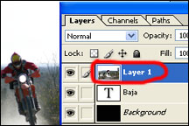  Layer>New>Layer  file>place  Find your image on your USB, Memory Card or Photo Folder, then click Place.  You can “transform”/resize your image to fill the space  edit>Transform  *Make sure to press & hold SHIFT while you drag a corner.  Your Layers Panel should look like the image on the right
Clipping Mask | With Layer 1 selected, Layer>Create Clipping mask
Move & Scale | Can move the image around with the “move” Tool in the tool Panel or  transform/resize in Edit
Save | 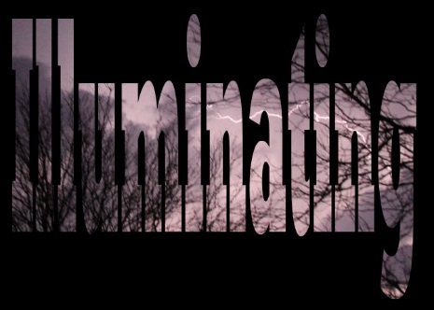  File>save  Save the Photoshop File in your Photo Folder  File>save as  Change the file format to a jpeg in your Photo Folder  FILE>SAVE AS  Find your USB/Flash Drive under Computer  Save to your USB/Flash Drive for a back up.

