How to Put a Photo Inside Text Using Photoshop
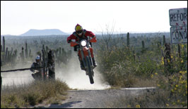
We are going to put this image inside text

This tutorial is to help you learn how to combine text with a photo so you can actually put any image inside a word of text. There are many techniques to accomplishing this same effect but this one seems to be the easiest and most effective.
1. Create a New Document (File>New), In order to achieve desired results you should probably make sure the new document has the same dimensions as the photo you are going to use to fill the text. Then use the Paint Bucket Tool (G) or go to Edit > Fill to fill the background with the color Black.
2. Then use the Horizontal Type Tool (T) and create a word or words that you want that span the whole new document. Then make the letters the color white.

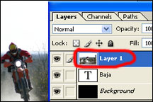
3. Create a New Layer. Go to Layer > New > New Layer or you can press & hold Shift > Ctrl > N (shortcut). To add your photo onto the new layer, go to File > Place. Find your photo on your USB, memory card or documents, then click Place. Your layers menu should look like the example shown to the left.

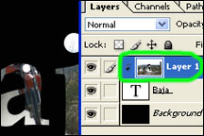
4. Then change the top layer to be a clipping mask. With the top layer selected (Layer>Create Clipping Mask)

5. Now you should be pretty much done, but you may want to move the text or photo around to change what’s showing through, to do this use the Move Tool (V) which is the black arrow on the Tool bar.
This is a great technique for creating posters or brochures. It is also very commonly used to make certain kinds of advertisements.

