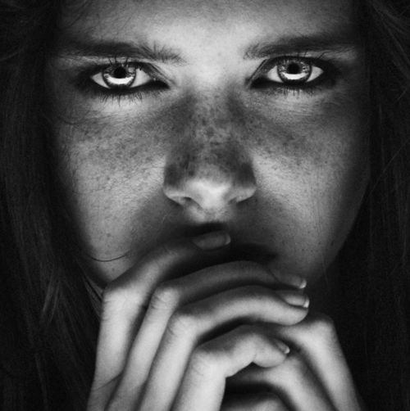
Nothing but B&W Journal Challenge
This is an open subject challenge. The only requirement is to shoot in Black & White, not to convert to B&W in Photoshop later. On a DSLR to change to B&W (Monochromatic), use the directions below. If you are using your photo, change the camera function to B&W (Mono, Tonal or Noir) *Remember to try vertical format too!
Take at least 5 different B&W shots for your journal. Journal prompt: How did you approach this challenge? Did you stick with one theme or try others? Why? How was it shooting in B&W? How did it impact your photos?

Change your Picture style to Monochrome
*This method will automatically take pictures in black and white. You won’t be able to change it back to color.
- Rotate the mode dial to P, Tv, Av or M. Program mode (P) is most similar to Auto mode.
- Press the down arrow and a list of ‘Picture Styles’ will appear.
- From this list select Monochrome then pressSET

Change the Ambience Selection to B/W
*This method will automatically take pictures in black and white. You won’t be able to change it back to color.
- Rotate the mode dial to CA, Portrait, Landscape, Sports or Night Portrait.
- Press the Q button and then the Up/Down arrows to highlight ‘Standard Setting’.
- Then use the Left/Right arrows to select Monochrome
- Press the Down arrow to select the ‘Effect’ bar and then the Left/Right arrows again to select B/W
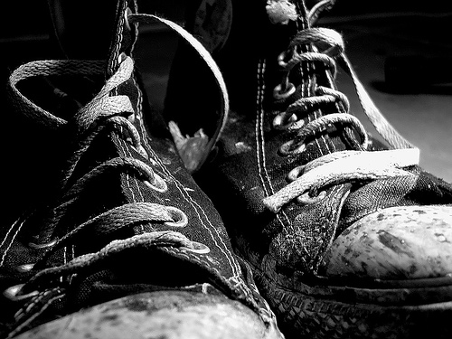
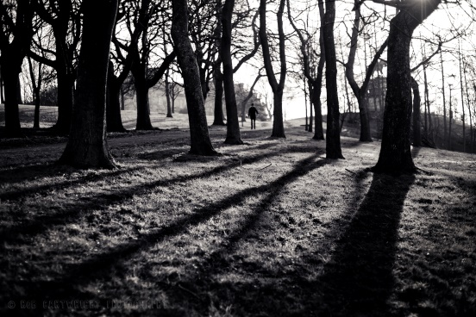
Themes/Ideas to Shoot:
*Landscapes
*People
*Still Life
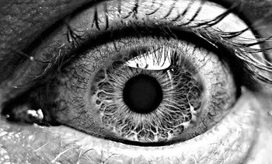
*Cityscapes

