Journal Challenge
Night Moves
Show a sense of movement through the frame. Of course, working in low light usually requires a longer shutter speed, so the challenge became creating a sense of motion through the dark within the context of the space being depicted. A tripod is a MUST! Slower Shutter. Test apertures. Start at ISO 3200.
Take at least 5 different showing motion at night for your journal. Journal prompt: How did you approach this challenge? How was it shooting at night to capture light movement? How did it impact your photos? Were some shots easier than others?
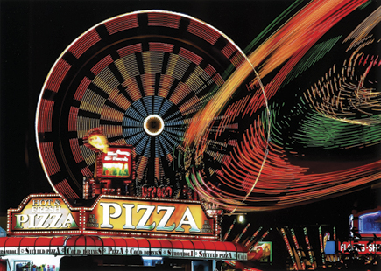
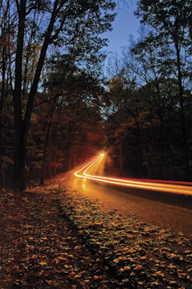
Jeff Miller caught the spirit of the place in both the static food booths and spinning rides in one frame. He worked with a Nikon D200 and a Nikkor 18-135mm lens atop a Manfrotto 055MF4 tripod. Exposure at ISO 500 was f/22 at 1.6 seconds.
The vehicle became just a streak of light traveling down a country lane in this photo by Ron Landis. He photographed with a Nikon D700 and a Nikkor 28-200mm lens with an exposure of f/14 at 13 seconds.

Kristy Burris made this emblematic shot at the Detroit Electronic Music Festival with a Nikon D200 and a 50mm lens; exposure was f/1.8 at 1⁄6 sec.
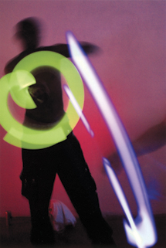
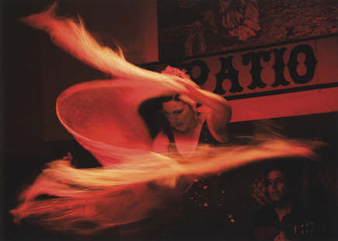
Kristy Burris made this emblematic shot at the Detroit Electronic Music Festival with a Nikon D200 and a 50mm lens; exposure was f/1.8 at 1⁄6 sec.
Kristy Burris made this emblematic shot at the Detroit Electronic Music Festival with a Nikon D200 and a 50mm lens; exposure was f/1.8 at 1⁄6 sec.
Emilio Fernandez saw the swirling shawl of this Flamenco dancer as fire and used a slow shutter speed to capture the energy of her movement. Exposure with a Canon EOS-1Ds Mark II at ISO 420 was f/8 at 1⁄15 sec
Kristy Burris made this emblematic shot at the Detroit Electronic Music Festival with a Nikon D200 and a 50mm lens; exposure was f/1.8 at 1⁄6 sec.
Emilio Fernandez saw the swirling shawl of this Flamenco dancer as fire and used a slow shutter speed to capture the energy of her movement. Exposure with a Canon EOS-1Ds Mark II at ISO 420 was f/8 at 1⁄15 sec

