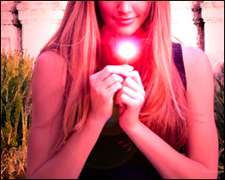
Magic Effect
This tutorial will show you how to create a magic effect or glowing flame effect that can be added to virtually any digital photo.

1. Add brightness and lots of contrast.
(Image>Adjustments>Brightness/ Contrast)
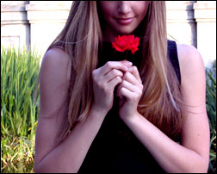
Brightness: +11
Contrast: +20

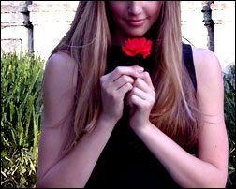
2. Isolate the subject from the background. Use the quick selection tool to select the subject. After selection, create a new layer. Layer>New>Layer
3. Next, click the Add Layer Mask button on the bottom of the Layers panel

3. Apply a Watercolor Filter to a new layer with only the background on it (Filter>Artistic>Watercolor). Then merge the layers together.
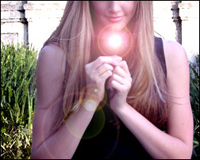
4. Render a 50-300mm Zoom Lens Flare with an intensity of about 129. Make sure it’s over the Rose. (Filter>Render>Lens Flare)

Optional:
Render Lighting Effects with the settings like the picture on the right. (Filter>Render>Lighting Effects)

