**[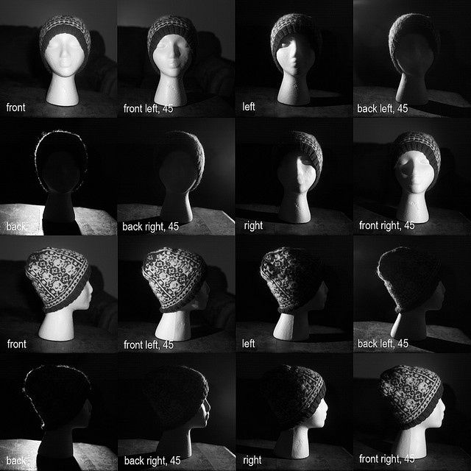](http://www.flickr.com/photos/keribeth/4248058393/)**Lighting Exercise