Lighting Direction

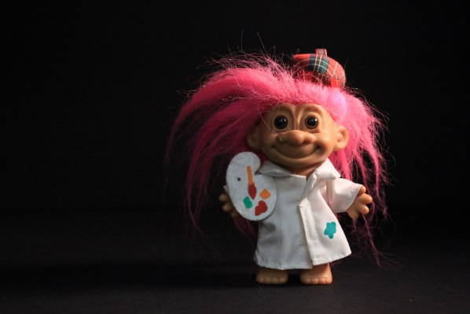
*Set Camera to M (Manual Mode), use the light meter to achieve the best exposure.
Right Side Light
-Open Right door of Black Light Box to place light in
*Top and Left should be covered
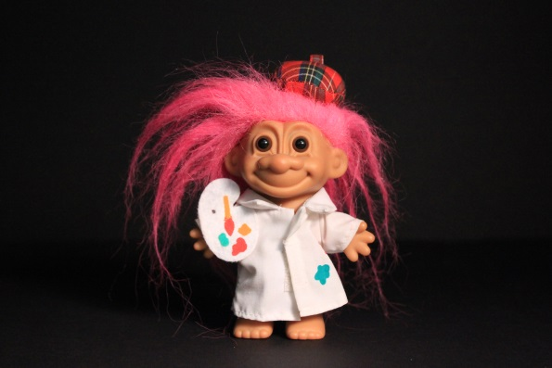
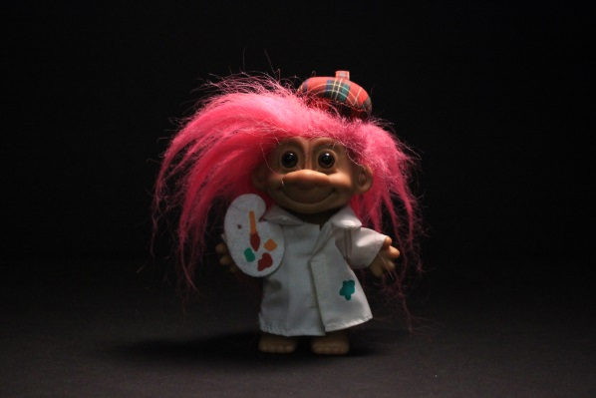
Front Light
-Place light in the Front opening of the Black Light Box
*Top, Left & Right should be covered

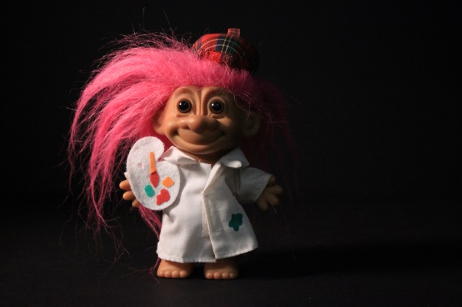
Top Light
-Have someone help you hold the light through the top of the Black Box
*Left & Right doors should be covered

Left Side Light
-Open Left door of Black Light Box to place light in
*Top and Right should be covered
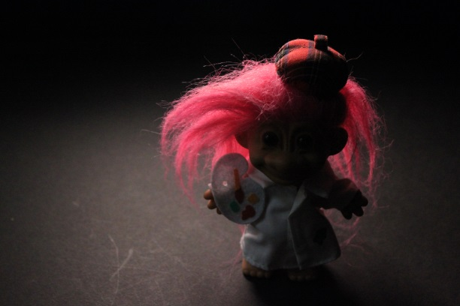

Back Light
-Open Left door & place the objects back side toward the Left door. Open Right door & take the picture through the Right door.
*Top should be covered

