Light Painting Photography
Light orbs, fire wheels, light drawings, 3D light extrusions and more - they're all heaps of fun, super creative and surprisingly easy to do!
All you need is your DSLR, a tripod, some kinda light, maybe some string, and if you're up for some real excitement, then bring some sparklers, or better yet, some steel-wool and a lighter!

1) What to wear?
No, seriously, this can be important. If you don't want to show up in your photos as this ghostly semi-glowing blur doing the 'painting', then it's best to wear dark clothes that won't reflect your own torch light. Also, if you're doing something more dangerous like a fire wheel (whirling around a fist-full of burning steel-wool on the end of a length of string), may I suggest using OLD clothes, a hat, and some sunglasses to prevent bits of molten metal causing you any regret/burns!
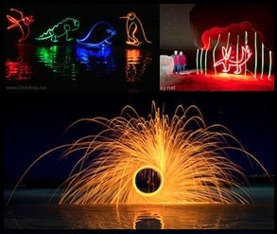

2) Picking your location:
You really can do these anywhere you like, except maybe for the fire wheel one, which you'd probably better do outside, somewhere that's unlikely to start a wildfire. The main constraint is that it's got to be at least dark-ish to enable you to take a long/slow-enough photo that you can draw something before the scene becomes over exposed. It doesn't have to be pitch black - in fact, having some ambient light to allow the background scene to show up in the picture can make for a much more interesting shot than just light scribbles suspended in blackness. So pick somewhere scenic, and abide by your composition rules. If you're getting fancy, perhaps try to find somewhere where the foreground is actually a bit reflective, like poolside, or standing on the wet, glossy sand on the beach, as this'll give you awesome reflections of your light paintings which looks fantastic.

3) Whatever lens you want:
It depends how wide your scene and light painting is going to be. A standard-ish lens around the 24-105mm length is pretty versatile. Wider perhaps for a fire-wheel as they can be pretty big! If you don't have a very wide lens, then just stand further back!

4) Get your camera on a tripod:
Yep, you do need one, or at least, a place to rest the camera so that it doesn't move during the photo, which can be quite a long time - 30 seconds or even longer!

5) Frame up your shot:
Best to do this now, before you start focusing etc, because on some lenses when you start zooming in and out to compose your shot, it throws off your carefully pre-set focus you'll be doing next. Don't forget your composition rules like rule of thirds etc, and ensure that you're shooting wide enough to fit in your whole intended light drawing.

6) Focusing:
The basic trick here is that you have to pre-focus your camera (using Auto Focus), and then switch it over to Manual Focus to 'lock in' that focus before you start taking shots, because as usual in these low-light situations, the camera will often struggle to find anything to focus on if you just leave it to it's own devices. It's easier to pre-focus with a friend - get them to go and stand where you're intending to do your light painting, and then have them shine a torch or something at the camera, or alternatively you shine a torch on them to make them visible - either way, it should be pretty easy to Auto Focus on them (by half-pressing your shutter button until you hear that little telltale 'beep'). Once it's found focus, then take your finger off the button, and find the Auto Focus / Manual Focus (AF/MF) switch (usually on the side of your lens) and switch it over to MF. Now, providing you don't accidentally twist the focus ring on your lens, the camera's focus is now 'locked in' and we don't need to worry about it from now on. Brilliant.

7) Camera settings:
Obviously there's many ways to skin a cat, but basically, I'd recommend using 'Time Value' TV mode on your camera's Mode Dial (this is the same as 'S' mode on non-Canon cameras). This is the mode where you select whatever length of shutter speed you want, and the camera works out what aperture / f# must go with that to produce a correctly exposed photo (or, if you've adjusted your 'Exposure Compensation' EC, then to produce you a photo at whatever brightness you've asked for - sometimes these low-light shots are supposed to be a bit dark, so perhaps experiment with setting your EC down a bit to -1 or something to get this effect).
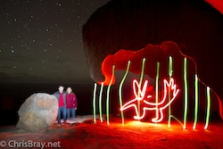
Virtual caged animal
Scroll your shutter speed out to whatever length you think you'll require to do your light painting. Better too long than too short! 10 seconds (looks like 10 " on the camera display) is plenty for a simple light drawing, my light orbs take me more like 20 seconds, but doing it for longer can look nicer and more 'solid'. Bigger more complex light painted scenes can take 30 seconds or more! To go longer than 30 seconds though you'll need to switch over to 'Bulb' mode on your camera, and either plug in a timer/cable-release (or use a rubber-band to hold something like a stick or a pencil against the shutter button - see my 'Shooting Star Trails' photo tutorial for more info on this, and how to set your settings in Bulb mode).
As for your ISO, it doesn't really matter too much in TV (aka 'S') mode. Basically if you ramp up your ISO making the camera more sensitive, then the camera will just select a smaller aperture hole (bigger f/#) in your lens because it doesn't need so much light anymore. This means your Depth of Field will get bigger, with close-up and far-away things both in focus - up to you if this is what you want or not. You don't want to turn your ISO up too far though, because a) you'll get noisy/grainy photos, and b) you might not be able to get the camera to take a photo as long/slow as you're asking for if the ISO's set too high/sensitive (ie it'll sit there flashing the f# at you as a warning). As a starting point, perhaps have your ISO around 200 or 400. Experiment!!!

8) Three, Two, One...
If you're doing this by yourself then using the camera's inbuilt 10-second countdown timer (in you're 'Drive Mode' options) is great, allowing you to start the countdown, and run around into position and wait to hear the shutter click open before you start 'painting'. As with most things in life however, light painting is more fun with a friend, so then you don't need any countdown timer, they'll start the photo when you yell out "three... two... one... GO!" and start 'painting' whatever it is you're going to paint. Now we have a choice to make... What kind of 'light painting' do you create?
The possibilities really are endless, but some common categories would include a) simply drawing a picture, b) creating a light orb, or c) creating a wheel of fiery-sparks. There are of course many variations on these themes too, such as drawing a picture with a sparkler, or a spiralling wheel of light rather than fire, or setting up quite elaborate techniques to generate interesting light patterns - whatever. The basic theory is the same for all types, so you're all set ready to go. So, what is it you want to draw?

Basic light drawings:
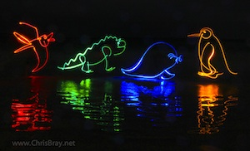
Galapagos animals drawn with lights
This is super easy - in theory! Pretty much all you're doing is drawing an image in mid air with some kind of glowing light source (like a torch, or it could be a sparker, or whatever) and the path your light follows will trace itself into your photograph as a glowing trail. It's actually harder than it looks to remember where you've already drawn - it's like trying to draw with your eyes closed, but practice makes perfect.
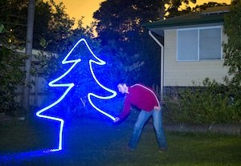
Drawing with light!
If you're using a normal 'torch' you have to be careful never to point the actual beam of the light right into the camera lens, as that'll flood your image with light and 'blind' the whole scene. So it's actually a lot easier to use some kind of glowing light source rather than a narrow, bright-beamed torch. Some ideas that have worked well for me include sticky-taping some semi-transparent plastic cap over the end of my torch (such as the lid from my deodorant can or something) as this not only turns it into a nice even, non-blinding glow, but also lets you chose some interesting colors other than just white torch light. Better yet, your smartphone / iPhone - download one of the myriad of different torch apps that make the LCD screen glow whatever color you want - this is a great easy way to get creative with colours. The trick is that you probably want to be able to turn your light on and off during the picture, so that you can 'lift the pen off the page,' so to speak, so that the image doesn't have to be drawn from one continuous line.
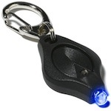
Photon
Micro-Light II
iPhone hint: set a screen-captured image of the torch app's blank color screen as your phone's background photo. You can then turn it on and off by activating / deactivating your iPhone with the top button.
I have to say though that by far THE BEST LIGHTS to use in my experience are these tiny little LED 'Photon Micro Lights II' as they come in heaps of different colors, have an easy squeeze on and off switch (and also a separate click on/off for when you need it to stay on by itself, like for light orbs mentioned below), and are just the right brightness that you don't need to worry about blinding the camera if you point it directly at the lens - they are so easy to use, just wave them around any-old-how and you get an awesome light trail.

Light Orbs:
These can look amazing, and although the technique - once you know it - is pretty easy and straightforward, as you'll soon discover, getting a nice spherical orb is a bit of a challenge, and getting something as perfect as those inspiring 'Balls of Light' scenes created by Denis Smith who has made these photos famous, clearly requires a huge amount of skill, creativity and patience. Still, with very little practice really, you can easily get your light orbs to look as good (as bad?) as mine. Here's how I do it:
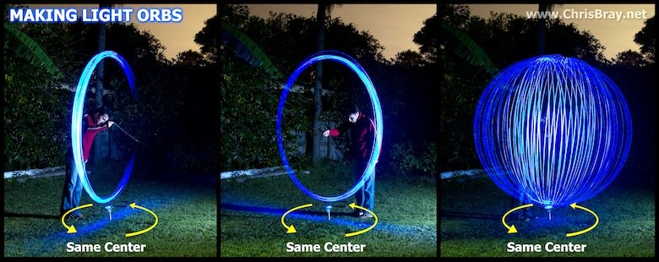
How to make a light orb! The spike in the ground is only to show you the centre point.
Firstly, you need some kind of evenly glowing light source (not a direct beam like an un-capped torch), and again, the best lights I've found for this are those little LED 'Photon Micro Lights II' that I mentioned above.
The basic theory is that you attach the light to a length of string (perhaps start with about 1 meter?), switch the light ON, and then commence whirling the light around and around in a circle, while slowly (and carefully) shift yourself around in a circle, ensuring that the base point of your orb / spinning circle always sweeps over the same point on the ground - so you basically shuffle around the outside of a point, looking inwards towards it, whirling your light in front of you. To start with, it may help if you physically mark that centre point on the ground with a leaf of something, to ensure you keep that orb centred as you circle around it.
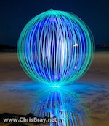
Orb inside an Orb!
Another important tip seems to be to try your best to keep your spinning hand as motionless and centred as possible as you whirl the light, and hold in in tight close to your body, rather than doing big erratic arm whirls - it'll give you a neater sphere with more control.
I've played around with tying multiple lights to the string at different lengths, and that way you can get spheres within spheres, giving different coloured cores etc. It's pretty cool. Have fun, and show us what you get by sticking some on our Facebook page if you can, that'd be great!

Fire Wheels:
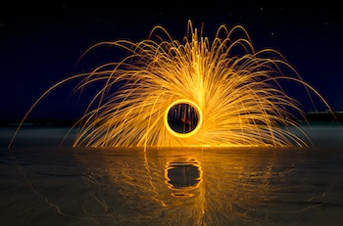
Fire wheel of burning steel wool!
This is one of my favourites - not only does it look spectacular, but as with anything involving fire and sparks and showers of molten metal - it's just so much fun to do! All it is, is simply getting a handful of steel-wool, tying it onto a length of string, lighting it, and whirling it around. "How do you light steel wool?" I hear you ask. "Metal Doesn't burn!?" Yes, my friends, it does. Spectacularly. Basically, because the metal fibres are so fine, and by whirling it around and around you're forcing so much air (and thus importantly, oxygen) to rush through it, the combination is indeed flammable, and the steel wool will burn/oxidize rapidly generating so much heat that it melts into tiny gobs of brightly burning/molten metal which then hurtle outwards from your swinging orbit in a beautiful arc. The effect is amazing.
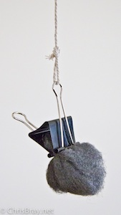
Steel wool ready for burning
It won't really fire-up until you start whirling it, just get it smouldering first with a match or lighter and start spinning. As I said earlier though, sunglasses and a hat are a good idea, and don't be surprised if you get some little char/burn holes in your clothes. Don't do it near anything flammable of course, or anything that could be scarred by these gobs of molten metal, like the paintwork on your neighbours car! You've been warned!
Quick tip: rather than simply tying the steel wool on to the string, tie one of those bulldog / stationary clips on to the string and then grasp the hunk of steel wool inside the metal clip. Otherwise the string may well melt and burn through, flinging the whole burning clump goodness knows where.
I should point out too, that you have to get proper, genuine steel-wool. Not just a metallic looking cleaning pad, nor even that bright silvery stainless steel springy wool stuff. Annoyingly a lot of 'steel wool' these days comes mated into little squares, pre-impregnated with soap powder. Even these ones don't burn well at all (better than nothing though, they kinda work, especially if you tease-out some of the finer, cleaner steel-wool from the centre of these square, sausage-roll like bundles). What you really want is just a hunk of pure steel-wool. The best place to get it is a hardware shop such as 'Bunnings' - you can even buy it as a roll, from the painting or finishing sections - very cheap this way.
I've seen some cool effects when this fire wheel technique is done inside a tunnel or similar, where the flinging off sparks then ricochet off the walls. Just a thought...

Variations and Extensions:
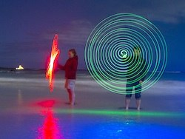
Spiral light painting
Perhaps try using a sparkler instead of a torch for drawing (the way to 'turn it off quickly' is to have a bucket of water handy to quench it into at the end of your drawing, and/or you can crumble away a gap in the sparker stick stuff so that it's only a certain length, to give you a shorter burn time.). What else? Why stay still while whirling your torch on a string - if you walked around, you'd end up with a super-cool spiral tunnel, and if you walked in a huge circle you'd end up with a 3D doughnut / toroid! (I haven't tried this, so let me know if it works). I managed to get a cool spiral effect by spinning the light on the string but poking my finger out from my spinning hand, causing the string to wind up around my finger making it shorter and shorter, so the light spirals neatly inwards. That was fun. Try whatever you want, run past the camera whirling a length of multi-coloured Christmas lights - the effect is pretty trippy. One last technique I've heard about but never tried is to tie a light onto a string, hang it from somewhere and set it swinging freely like a pendulum. I can imagine some pretty cool effects there!
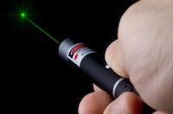
Using these same camera settings, you can also draw pictures using a laser pointer directed at a wall or something, making the little red dot to draw a picture, rather than having to actually stand out there in the photo and physically move a light source around. It's easier to do, but doesn't look as 3D as really painting in mid air with a light.
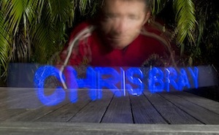
Light Extrusion using 'holo-paint' app
If you want to really blow your mind, read up on 'Light Extruding' - where using your iPad or iPhone and an app called 'holo-paint' ($5) you can type in a word or phrase, and then slowly move your iPhone through empty space while you take one of these long shutter speed photos of it, and the screen will in real time display a cross-section of wherever part of the phrase you're up to, basically allowing you to extrude the letters in 3D space by wiping your iPhone through the air. Very impressive! But before you rush out and buy it, I should warn you that it's rather hard to move it in a smooth enough path to make it all look neat.
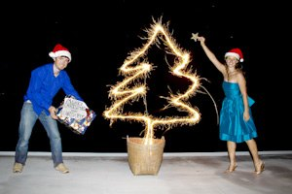
10 Sec sparkler photo with flash @ end

