Journal Challenge
From Above
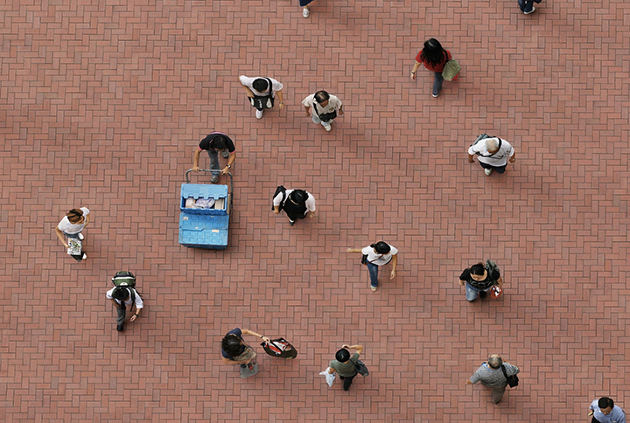
This is an open subject challenge. The only requirement is to shoot from above at a high vantage point. This point of view can be quite startling so be careful if you climb onto things and place to get the perfect shot. Can be shot in Color or in B&W. *Remember to try vertical format too!
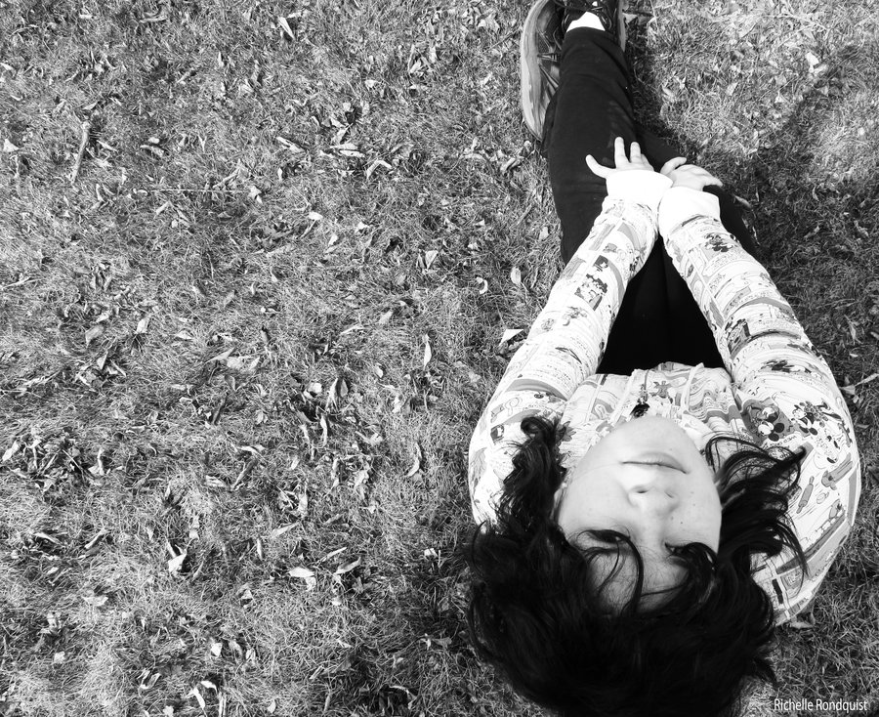
Take at least 5 different high vantage point shots for your journal. Journal prompt: How did you approach this challenge? How was it shooting at a high vantage point? How did it impact your photos? Were some shots easier than others?
