Journal Challenge
Found Still Life
Serendipity has its own rewards, especially when you go out wandering with eyes wide-open and a camera in hand. Take pictures that present themselves to you as you make your way on a trip, or just on the way to work. Each step is a journey, and a photographer is never bored, especially when the world is filled with such unexpected feasts for the eyes! Try not to alter the still life, change your viewpoint! *Remember to try vertical format too!
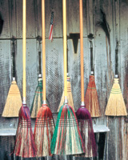
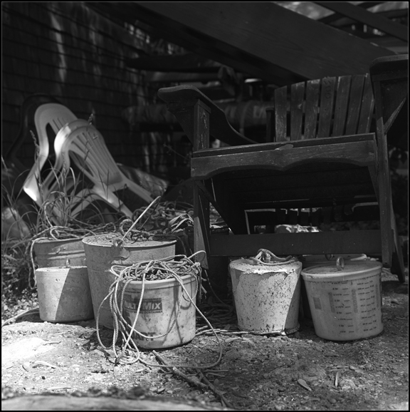
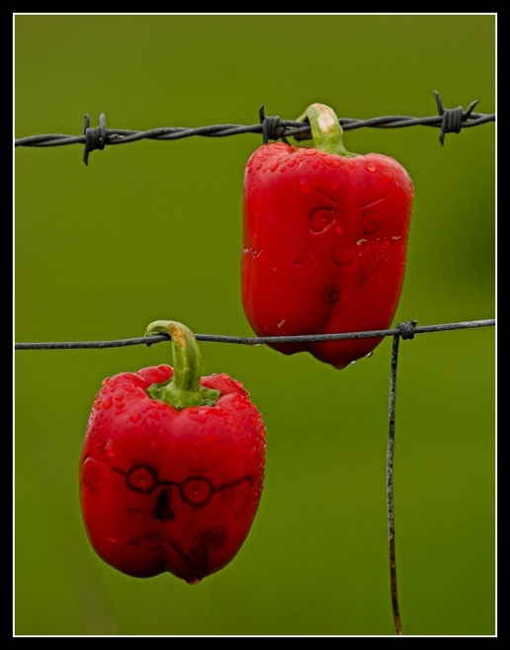
Take at least 5 different still-lives for your journal. Journal prompt: How did you come across this found still life? What about this found still life caught your eye to take the shot? Was there anything that you wanted to alter while shooting?
