Exposure & Metering

What is Your Light Meter?
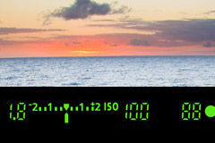
Your light meter is the part of your camera that read the amount of light coming into it through the lens. It will tell you whether you have too much or too little light coming in according to the settings you have set. It looks something like this:
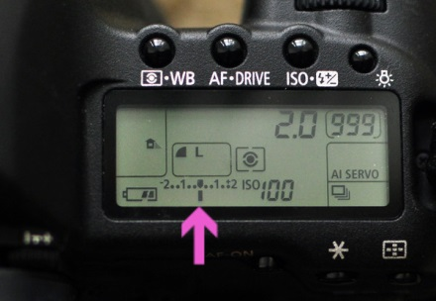

If your arrow or the little lines fall toward the +, then you have too much light and your image will be overexposed (or too bright.) If the arrow or the lines fall toward the -, you don’t have enough light and your image will be underexposed (or too dark.) When your light meter arrow is in the center on the “O”, or you have no lines moving toward the + or the -, then you have about the right amount of light coming into your camera to get a nice exposure.
*Keep in mind that all camera manufacturers display their light meter different. For instance, Canon’s light meter will look opposite of this–with the positive on the right and the negative on the left. No matter how your light meter displays through the viewfinder or on the back of the camera, know that lines in the positive direction are overexposed and in the negative are underexposed.
When photographing with natural light like the sun or a window, we don’t have a lot of control over the amount of light that is available. For instance, I can’t turn up or down the amount of light the sun produces on a particular day. But I do have control over how much light comes into my camera by using my manual camera settings–aperture, shutter speed, and ISO. Adjusting these three settings will give me different readings from my light meter.

Overexposed or Underexposed?

If your light meter is telling you that there is too much light coming into your camera and your photo will be overexposed, there are a few things you can do to let LESS light into your camera:
- close down the aperture
- increase your shutter speed
- lower your ISO
If your light meter is telling you that there is too little light coming into your camera and your photo will be underexposed, there are a few things you can do to let MORE light into your camera:
- open up your aperture
- lower your shutter speed
- increase your ISO
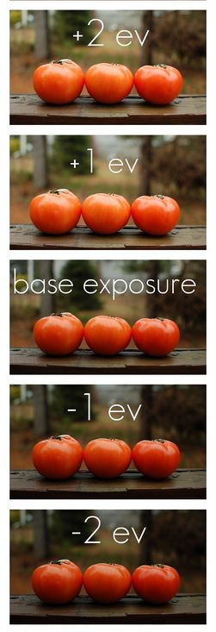
Your Light Meter isn’t Perfect!
Your light meter can sometimes be tricked in lighting situations where there are a lot of bright tones and a lot of dark shadows. Each time your lighting changes or you are shooting from a different angle or direction in relation to the sun, look at your light meter and take a test shot to view on the back of your camera. If your subject is too dark then you’ll need to take steps to purposely overexpose your image. If your subject is too bright, then you’ll need to take steps to purposely underexpose your image.
Your Assignment:
Take 5 pictures like the example to the right.
- Base Exposure (0)
- 1 Photo at +2
- 1 Photo at +1
- 1 Photo at -1
- 1 Photo at -2

