Embellished Photo Transfer on Wood

Here is one of the finished artworks. The first thing I did with this piece was the image selection process. There were several images from a trip to Italy and it was tough to narrow it down to just one. In fact, I didn't. I combined two of her photos using Photoshop layers, masking techniques and filters. Once the image looked the way I wanted it to, I created a mirror image copy of it to use for printing. *Note: you will want to use the highest resolution image possible and go ahead and set it to the exact size you plan on using for large format printing before taking it to your printer. You must print on plain paper, no glossy or thick stuff!
﻿
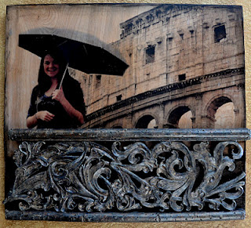

Here are some of the basic steps used in this project:

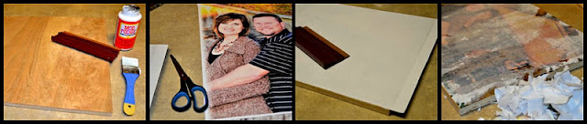
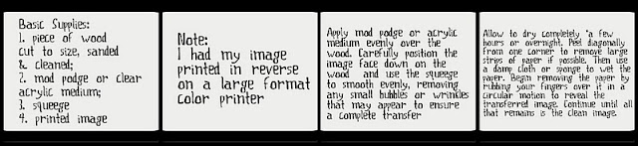
Once the transfer is complete you will be able to see the beautiful texture and grain of the wood through the areas that were originally white in your image. It gives such a wonderful look to the artwork. Looks great with color photos or black & white.
At this point I added the embellishments. I painted the sides in a brown/black and distressed the edges coming in to the picture. I also securely attached a wonderful architectural piece using screws and liquid nails. *Note: I also did a paint technique over the architectural piece to get the colors I wanted.... you can see the before colors here:
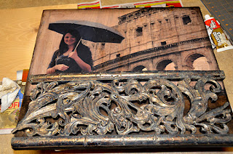

Here is an example of one of the other transfers I did. You can still see a little bit of paper on this picture as it was still "in progress" at this point. This image was embellished with a really great rustic metal corner piece in the bottom left corner. (I'll come back and post a final picture later)
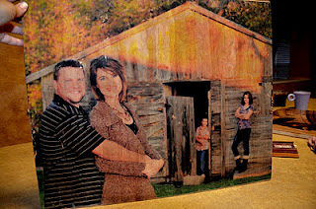
All of the transfers were wired on the back for secure hanging and finished off with a clear acrylic top coat to protect the images from fading.

