**[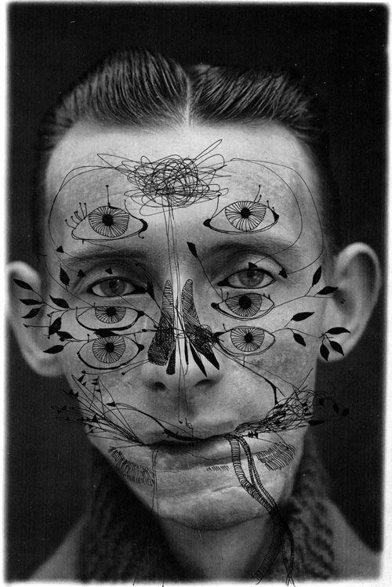](http://www.ashkanhonarvar.com/?page_id=295)**Draw on Me

**[](http://bsimple.com/Crowd50.htm)[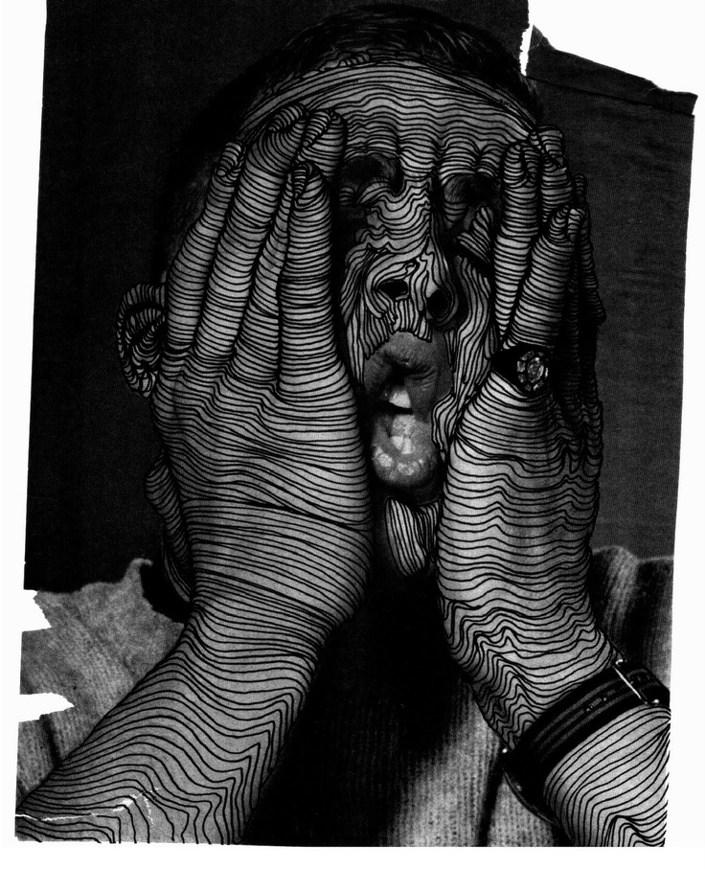](http://www.thedriptych.com/search?updated-max=2010-12-09T17:36:00-08:00&max-results=8)**