Journal Challenge
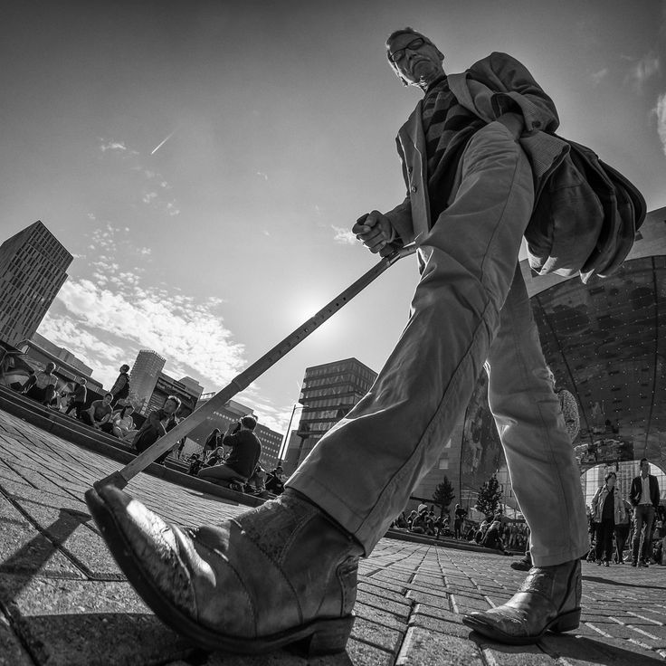
Down Low
This is an open subject challenge. The only requirement is to shoot in “down low” at a low vantage point. This point of view can be quite startling, especially with deep depth of field employed. Can be shot in Color or in B&W. *Remember to try vertical format too!
Take at least 5 different low vantage point shots for your journal. Journal prompt: How did you approach this challenge? How was it shooting at a low vantage point? How did it impact your photos? Were some shots easier than others?
