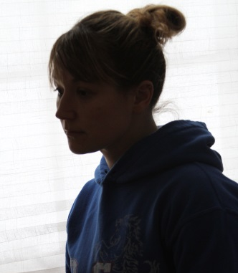
Double Exposure Portrait
- Open a portrait that is either backlit by a light or window.
- Open a landscape, cityscape or still life.

- Click on the second photo tab (circled below right), drag it down into the work space. It should look like the picture below right.
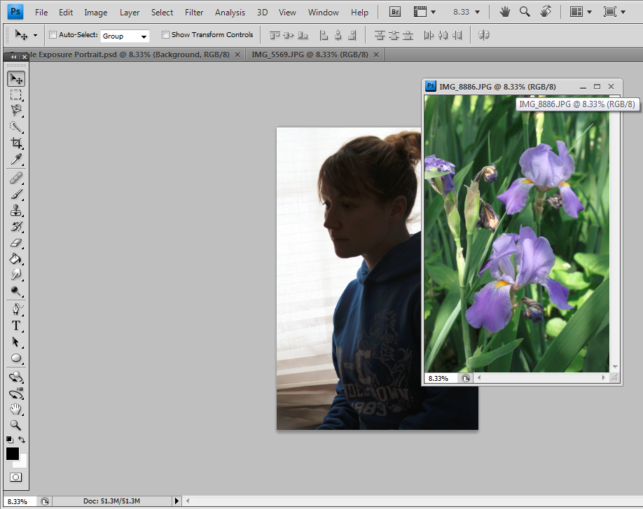
- Go to Image>Adjustments>Black & White

- Click and drag on the photo onto the portrait. You now created a new layer. See below.

- If you need to size the photo to fit the portrait, go to Edit>Transform>Scale. To scale proportionally, press and hold SHIFT and drag the corner out.

- Make sure you are still on the Layer 1 photo, go to Image>Adjustments>Black & White.

- In the Layer Panels, select Lighten or Lighten Color. Then use the Opacity scale to change the opacity of the photo to the desired effect.
