Double Exposure Look Using Photoshop
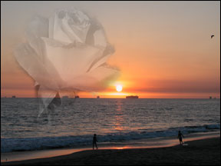
Introduction: This tutorial is to help you learn how to blend images together using masks. This technique makes it easier to make collages and artsy pictures. Ok, once you have the 2 pictures you would like to blend open in Photoshop:
1. Select All of the first photo (Select>All) and copy it (Edit>Copy).
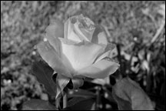
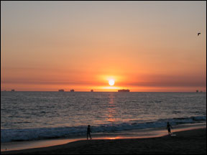
2. On the second photo, paste the first photo into it (Edit>Paste).
*If you second photo is too large, go to Edit>Transform>Scale. Make sure to hold SHIFT when scaling then double click to place the photo.
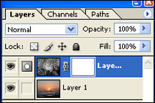
3. Then add a Reveal All Layer Mask to the top layer (Layer> Layer Mask>Reveal All).

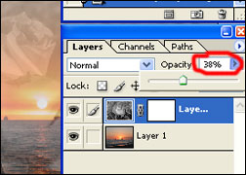
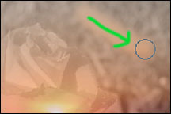
4. With the Layer Mask Selected, pick a good sized paintbrush and color all the areas black that you don’t want to see. *Make sure black is on top!
5. Lower the Opacity on the top layer to your liking, for this photo I lowered it to 38%.

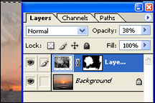
6. When you’re done your layer menu should look something like the picture on the left. You can also move the top layer image around by using the Move Tool (black arrow).

