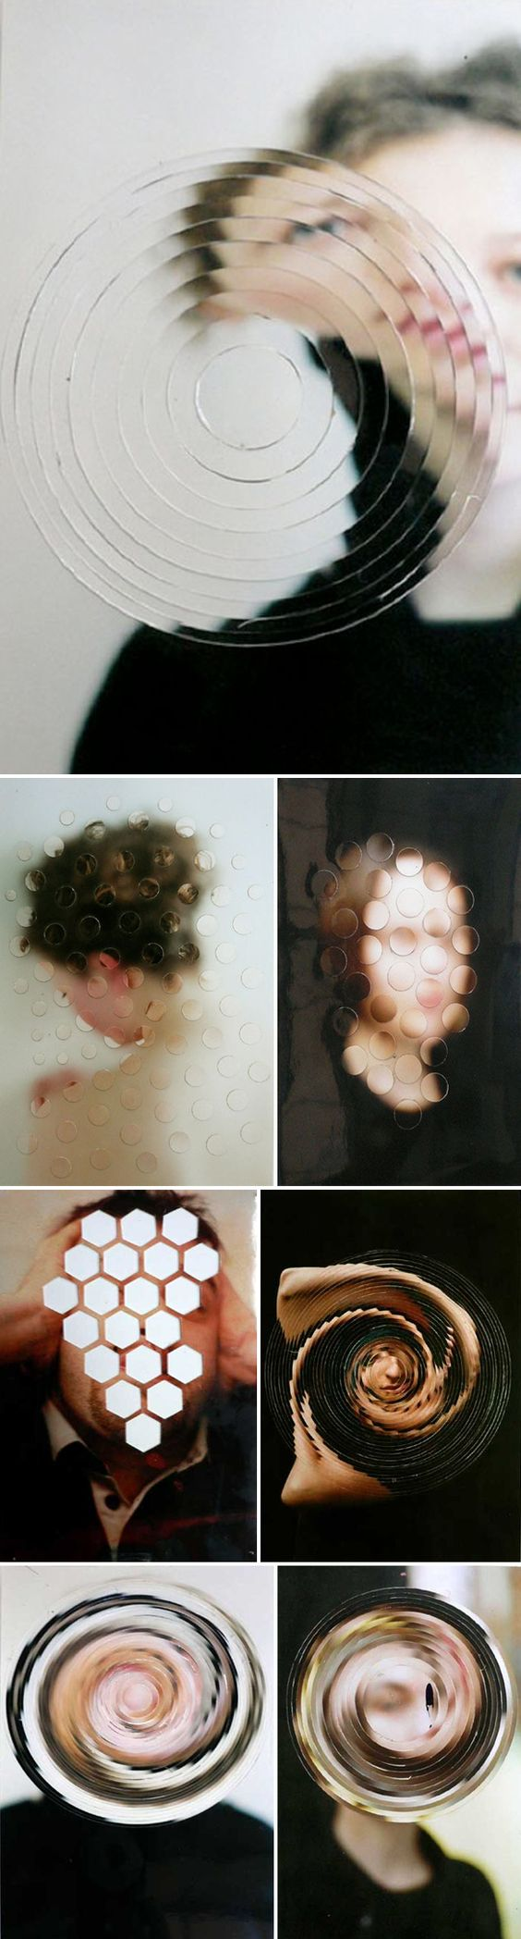
Dissect & Rearrange a Portrait
Take a portrait in front of a neutral background.
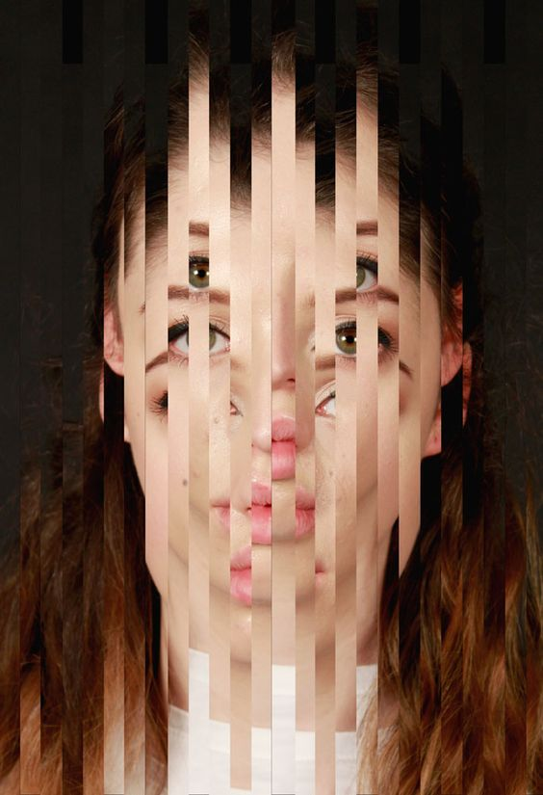
Cut the photo and rearrange the dissections to create an interesting effect. Use an X-acto Knife, circle cutter, shape punches, etc... then glue onto illustration or mat board. Can use Photoshop if using multiple images.
