Create a Portrait from Text
Step 1: Open Portrait in Photoshop
Step 2: Crop the Image around the face
*Using the Magnetic Lasso Tool to select the background
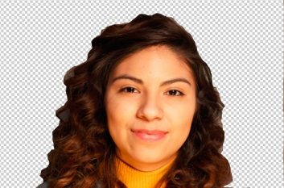
*Then press Add Layer Mask
Step 3: Press Ctl + I

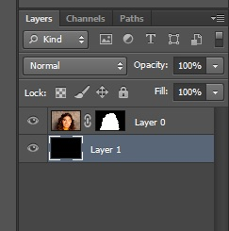
Step 4: Add a new layer: Layer>New>Layer

Step 5: Fill the new layer with black: Edit>Fill
*In the Contents Section, select Black, then ok
*Then place New Layer under the Layer 0
Step 6: Use brush tool and black to cover any areas not black
*Make sure you are selected on the layer mask – not Layer 1
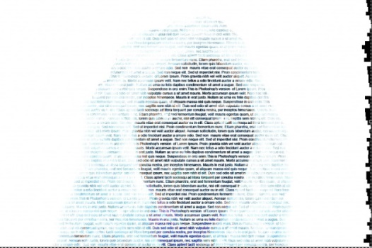
Step 7: Create a New Layer and then Select the Type Tool
*Click in the top left corner and drag to the bottom right to create a large text box
*You can type or copy & paste text into the new text box
*Font color: Black
*Picture to the right shows text being highlighted
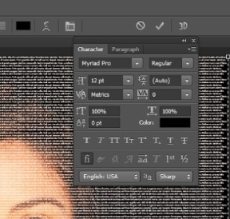
***Portrait Text Options
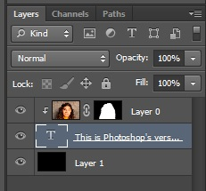

Step 6: Once your text is the desired effect, move the Layer 0 above the Text Layer.
Step 7: Right-click on Layer 0 and select Create Clipping Mask.

