Convert Color Photo to B&W
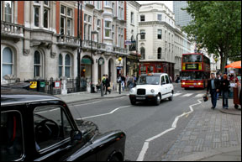
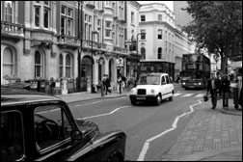

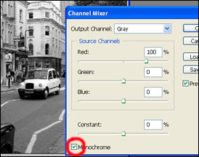
This section is to help you learn how to turn regular color photos into professional black and white photos. There are many other techniques of doing this but this one is surprisingly simple and is very effective.
Open your picture in photoshop and:
1. Open a new Channel Mixer adjustment layer.
2. Then click to check the box that says Monochrome to make the picture black and white (but don’t click OK yet).

3. Adjust the brightness percentages to fit the coloring of the picture. (To adjust the balances click on the sliders and drag them to the left or to the right).
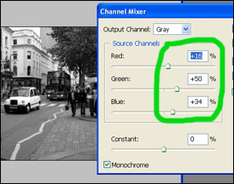
With the channel mixer you can accent the brightness of different colors by adjusting their percentages. For example, if you raise the red percentage the red bus in the picture will get brighter. There is no real exact way to balance a picture, the most common black and white is based on the red colors that’s why the channel mixer started out with 100% red. Try each color at 100% with the others on 0. Based on that, experiment and make it a mixture of different colors but when you find which colors balances you like, for the best results make sure their percentages add up to 100%.

