Convert a Color Photo to B&W
Objective | This exercise is to help you learn how to turn regular color photos into professional black and white photos. There are many other techniques of doing this but this one is surprisingly simple and is very effective
Open Image | open photoshop>File>Open or right-click on image from folder>Open with>Photoshop
Duplicate image | Layer>Duplicate Layer  Before you click ok, select New in the Destination drop menu  Name it “Channel Mixer BW”
New Adjustment Layer | 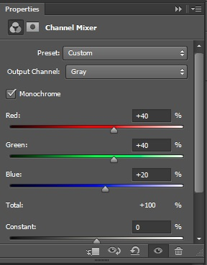  Layer>New Adjustment Layer>Channel Mixer  Click on the Monochromatic Box
Adjustments | Optional Step: Can make color (Red, Green, Blue) adjustments by moving the sliders.
Save | File>save  Save the Photoshop File in your Photo Folder  File>save as  Change the file format to a jpeg in your Photo Folder  FILE>SAVE AS  Find your USB/Flash Drive under Computer  Save to your USB/Flash Drive for a back up.
 | 