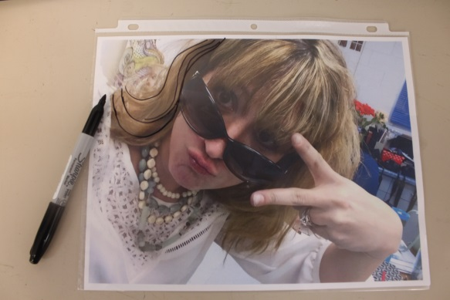
Collage Portrait

- Select a portrait of a real person; self-portrait, friend/family member, celebrity,
- Print the portrait FULL size. *Should be the entire page
- Place print in a sheet protector.
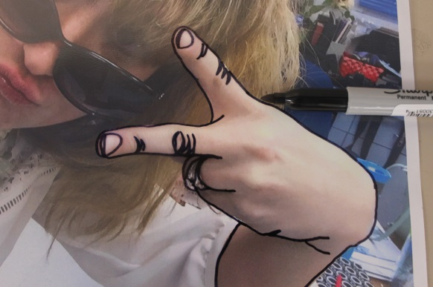
- Trace using a regular sharpie. Keep your lines solid and not sketchy. Draw as many details as you can – but you can always add more later.
- Trace your sharpie drawing onto a white 8 ½ x 11 sheet of paper using either a window or light table. *You do NOT need to get every detail because you are going to cover this paper with magazine and construction paper!
- Decide what color scheme you are going to use: Cool Colors, Warm Colors or Complementary (opposites on the color wheel like blue & orange) See the chart below.
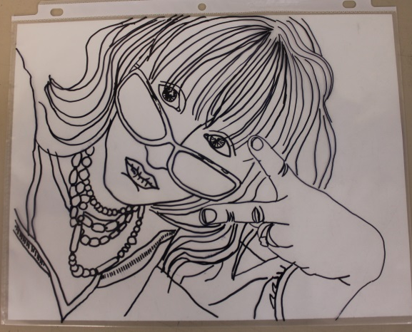
- Go through magazines to find your “colors” to be torn, ripped or cut into pieces to place on the white paper.
- Glue magazine/paper pieces onto the white paper. *Papers CAN go outside the lines!
*Periodically check the progress by putting the sheet protector over the collage to see if you need to add or take away this!
