Journal Challenge
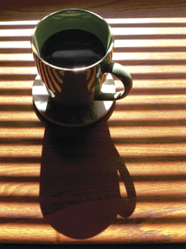
Cast Shadow
The use of shadows in images allows the photographer to bring enhanced form and content into scenes where other lighting conditions might have been less dramatic and graphic. Shadows not only allow us to redefine and refine form, they can also bring in hints of forms off the edges of the frame and add twists and turns in the image that less angled light would miss. Can be taken in B&W or Color. B&W may have a greater impact! Work with objects or places, no people.
Take at least 5 different cast shadow shots for your journal. Journal prompt: How did you approach this challenge? How difficult was it to get perfect shadow? How did it impact your photos? Were some shots easier than others?
