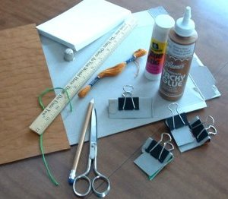
Bookbinding
Supplies you'll need.
- pencil
- index cards (4" x 6")
- choice of paper for cover
- heavy thread (waxed is suggested)
- heavy needle
- cardboard (cereal boxes work great)
- scissors
- glue stick
- "Tacky" glue
- ruler
- binder clips (large)
- awl (optional)

1. Separate index cards into piles
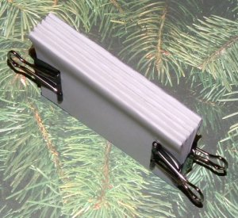
Separate the index cards into 6 piles of 4 cards each to create a book with 48 pages (6 x 4 x 2 = 48). You can make the book longer or shorter by adding or reducing the number of piles used for your book—just make sure it's an even number. In this tutorial, we'll use 6 piles. The number of cards in each pile depends on the thickness of paper, but for index cards, 4 per pile is a good starting point. If you use notebook paper, you might be able to use 6 or more pages per pile, but in this tutorial with index card pages, we'll use 4 per pile.
2. Create sets
Fold each pile of cards in half, making a good tight fold. This is called a set. Clip all the sets together with the binder clips to form a spine for your logbook.

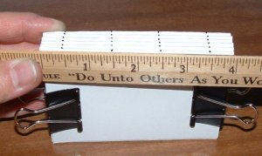
3. Mark spine with pencil
Using your ruler, we'll mark 4 points across the unfinished spine. Two of the points should be located about half an inch from each end, and the other two points should be roughly equal distance between the first two.
For our 4-inch spine, we'll create marks at ½ inch, 1½ inches, 2½ inches and 3½ inches (from this point on called A = ½, B= 1½, C = 2½, and D= 3½).

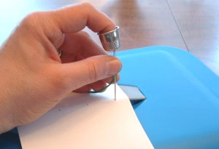
4. Punch holes through each set
Open 1 set of cards. Using a needle or awl, punch a hole through all the cards at each marked spot on the fold. Repeat for the remaining sets.

5. Thread the 1st set
Thread your needle with about 5 to 6 feet of thread.
Tie the ends of the thread together in a knot, leaving about a 4 inch tail.
Starting at A, put your needle down through the hole, come up at B, down at C and up at D. Pull thread tight.
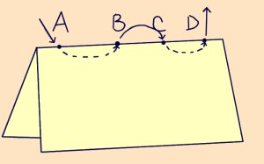
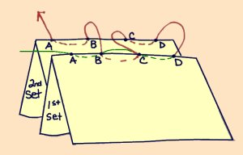
6. Thread the 2nd set
Hold second set of cards in back of the first set.
Put your needle down through D2 (second set), up through C2, down through C1, up through B1, down through B2 and up through A2.
Pull your thread tight as possible as you go. Now tie your 'active' thread with the tail left at A1 from Step 5.

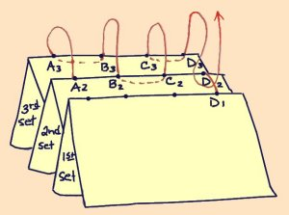
7. Thread the 3rd set
Hold 3rd set behind the second set.
Put your needle down through A3, up through B3, down through B2, up through C2, down through C3, up through D3 and hook your thread under the loop at D1 and D2 (where the two previous sets are joined).
Pull your thread tight.

8. Thread the 4th set
Hold 4th set behind the third set.
Put your needle down through D4, up through C4, down through C3, up through B3, down through B4 and up through A4. Pull thread tight.
Hook your thread under the loop at A2 and A3 (where the two previous sets are joined)
9. Thread the 5th and 6th sets
Attach sets 5 and 6 exactly the same way you attached the 4th set by repeating steps 7 and 8.
Pull thread tight and tie off with tail at end of set 6. Make a good knot and cut, leaving about a half inch tail.
Use your binder clips to hold your book tight.
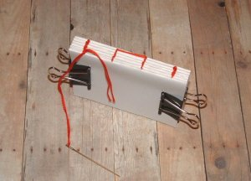
10. Measure cover pieces
Measure your "book", add 1/8 inch length and width. Measure the binding, squeezing the binding tight to get a good measurement. (Roughly 3 1/8 x 4 1/8 x 7/16. You want a smaller binding piece).
Transfer your measurements onto your cardboard.
Cut out the pieces as one for now.
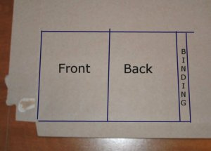
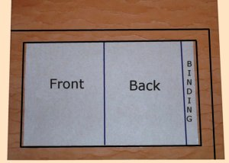
11. Measure out cover paper
Take choice of paper and lay it face down.
Place your cardboard on top. Leave ½ inch border of paper around the cardboard. Add 3/16 inch to the length to accommodate the fold around the binding.
Cut out choice paper. (Mark your ½ inch borders on the paper).
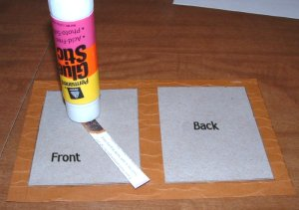
12. Glue cover pieces together
Cut apart your cardboard pieces.
Using your glue stick, glue the front cardboard cover to the back of your decorative cover paper. Use your drawn ½ in. lines for placement.
Do the same for the back cover, gluing to opposite end of your cover paper.
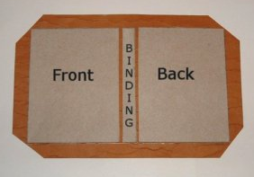
Now glue the spine of cover and place between the front and back covers, leaving equidistant room.

13. Miter cover corners
Cut off the corners of the cover's decorative paper. It'll make the corners neater later.

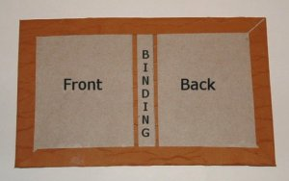
14. Glue down cover flaps
Using the glue stick, glue the edges of the paper, fold them over the cardboard and press down tight.
Fold your cover into a book, creasing the folds well.

15. Glue down front endpaper
Using your glue stick, glue the front inside cover of your book (cardboard side).
Place pages inside cover, making sure it is tight to back binding. Press front page against cover of book. Press tight. The first page of your first set and last page of your last set will become the endpages of your book.
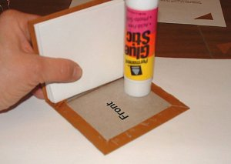
16. Glue spine and back endpaper
Apply tacky glue along the cardboard binding of the cover (and only there). Use a glue stick on the back cover of book (cardboard side).
Position page and press tight.
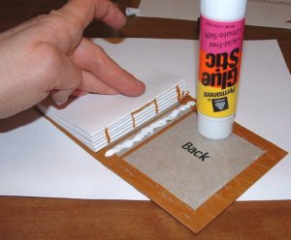
17. Set bindings
Use the binder clips (using left over cardboard to protect your book) on the sides of your book to keep securely closed. Don't put a binding on the spine, though—just on the three sides of the book that will open.
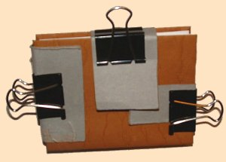
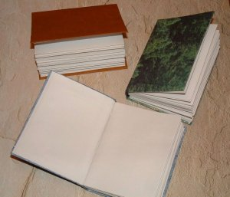
18. Let dry and you're done!
Wait at least 8 hours for the glue on your logbook to dry before removing the bindings and opening or using your book, but that's it—you're work here is done!

