Aperture Bracketing #1
- Find objects in & out of the classroom that you are going to take 3 pictures of. Needs to be the same composition.
- Set the camera to Aperture Priority (AV).
- Set the aperture to f4.5 by pressing and holding the AV +/- button and moving the dial.
- Focus on the foreground object and take a picture.
- Repeat step 3-4 for each aperture setting. (if the camera allows you to go to f4.0, please start there first!)
  - Example apertures: F4.5, f8, f29
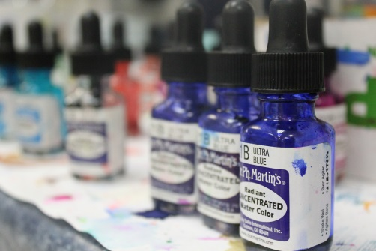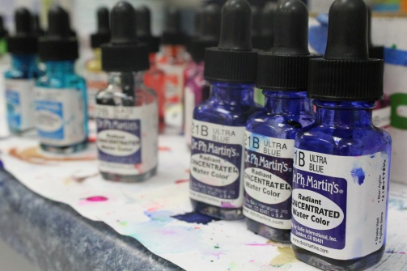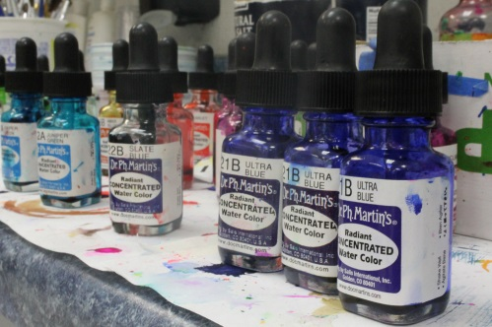
F4.5 f8.0 f29

Aperture Bracketing #2
- Next take one picture where you are focusing on a middle ground object using a large aperture and then a small aperture.
- Next take one picture where you are focusing on a background object using a large aperture and then a small aperture.
Background & Foreground are in focus with a small aperture
Background & Foreground out of focus with a large aperture

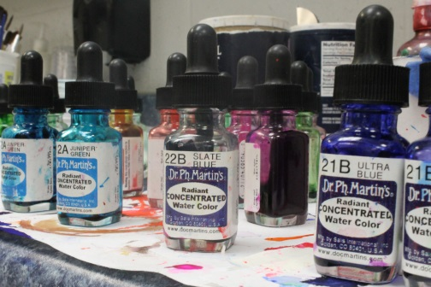
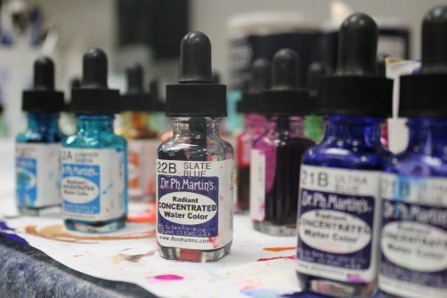

In Focus for both shots

