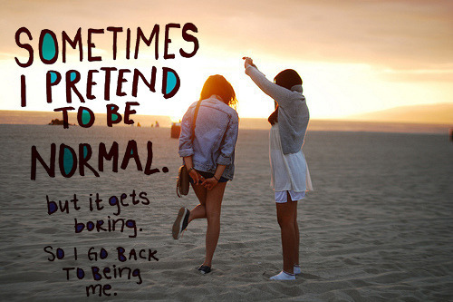
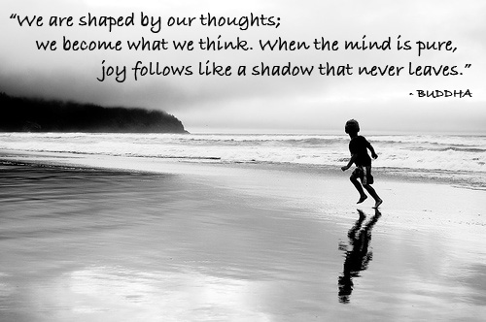
Adding Text ON yourPhoto
- Use a photo that you took and add text ON it.
- Text can be typed using Word document, Photoshop or handwritten
- Photo can be in color or B&W
- Text can be a quote, song lyric, poem, something you say, etc.. *Make sure to cite the author, writer

