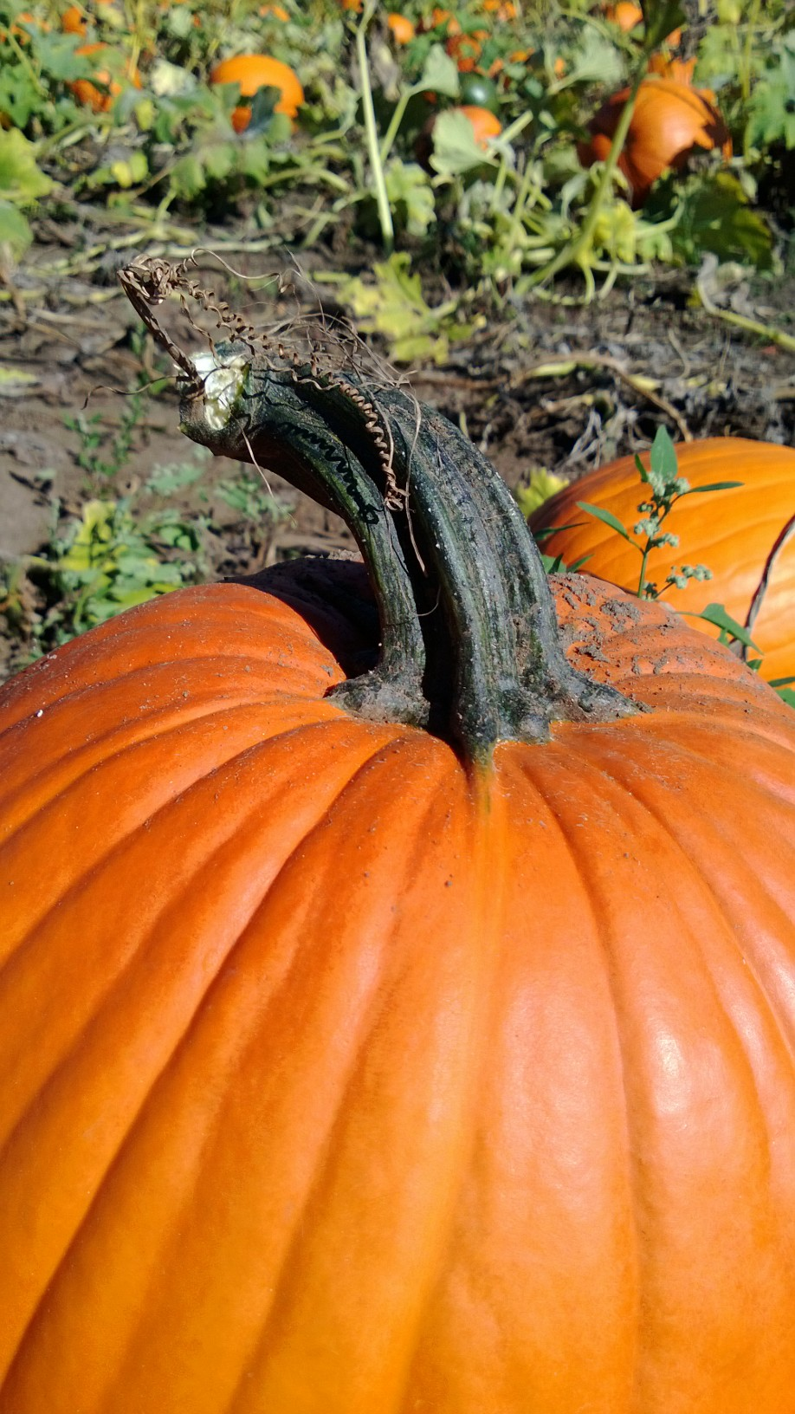

**“He'll rise out of that pumpkin patch and he'll fly through the air with his bag of toys. The Great Pumpkin will appear and I'll be waiting for him! I'll be there! I'll be sitting there in that pumpkin patch... and I'll see the Great Pumpkin. Just wait and see, Charlie Brown.”-Linus from *It’s the Great Pumpkin Charlie Brown***