Adding Background Textures

To this in just a few simple steps:

- Begin by opening an original photo in Adobe Photoshop CS4
(File -> Open)

2. If you need to touch up your photo, like brightening or accentuating certain colors, go for it!
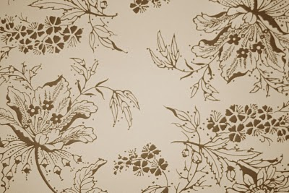

- Next to add a little bit of interest to the background you can add a texture overlay to the photo.
There are many textures available out there like on http://www.brusheezy.com/textures
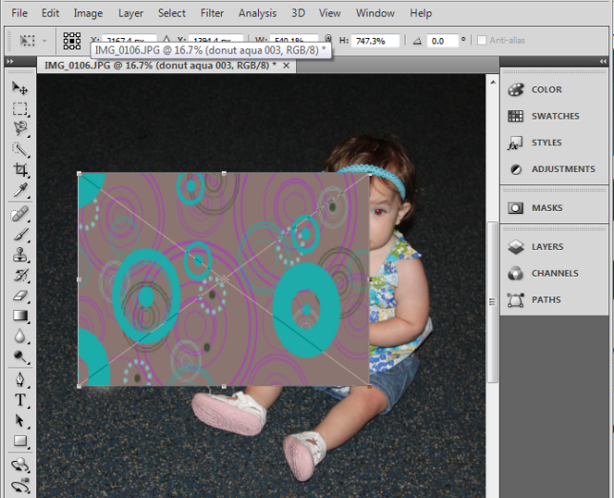
Then go to File > Place. Find the texture that you want to use with your photo. Click Place.

4. The texture will appear on your photo with the transform scale on it. In order to get it to cover your photo proportionally, you need to press & hold the Shift button and the mouse at the same time to scale the texture. Your photo should no longer be visible because the texture file will be on top of it.

5. By placing the texture file on top of the photo we have now created two seperate layers within the photo document you’re working on. If the “layer palette” is not open go to (Window -> Layers) and you will see the two layers there, the background layer (which is your photo) and the texture layer. Click on the texture layer, and you will see an OPACITY slider in the upper right corner of the Layers palette. Click on this and begin sliding it to the left to lower the opacity of the texture layer. You will notice your photo begin to look a little bit like this:
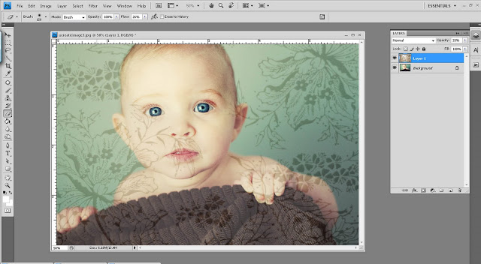

You can now see the photo through the texture layer. Adjust the opacity until you get the look you desire.

6. What we want to do next is remove the texture from any areas on the photograph where we don't want it to appear, ie. skin, clothing. To do this we will use the Eraser tool (on the left tool bar, it actually looks like an eraser). Once you have selected the eraser tool click on the texture layer and then click OK. You can change the size of the eraser by changing the Brush Size Diameter on the top. I prefer to use a soft brush and will also adjust the opacity of my brush depending on the area on the photo I'm working on so that I can blend the areas with texture and without texture smoothly. Use the eraser tool by clicking your mouse and while holding drag it over the areas of your photo where you wish to remove the texture. Be sure you are still on the texture layer while doing this.

*If you want your background texture to be more Opaque, go back to the Opacity Slider to change the opacity to 100% or whatever looks best!
